Promethues and Grafana

1. Install Prometheus on a server and configure prometheus.yml.

PURPOSE:
- Install Prometheus as a monitoring server.
- Configure Prometheus using the prometheus.yml configuration file.
- Monitor the Prometheus server itself.
- Add additional targets such as Node Exporter or application servers.
- Run Prometheus as a system service.
- Verify that metrics are being collected successfully.

OBJECTIVE: To install Prometheus on a Linux server, configure it to collect metrics from itself and other monitored systems, and verify that it is successfully scraping metrics through the Prometheus web interface.

ARCHITECTURE:

+---------------------+
| Prometheus |
| Port: 9090 |
+----------+----------+
|
|
Scrapes Metrics
|
-----------------------
| | |
Node-1 Node-2 Applications
:9100 :9100 :8080

PREREQUISITES:
- Ubuntu 22.04/24.04 Server
- Sudo privileges
- Internet connectivity
- Firewall allowing TCP Port 9090

STEP BY STEP IMPLEMENTATION:
Step 1: Update the Server
sudo apt update
sudo apt upgrade -y
Purpose: Updates the package repository and upgrades installed packages to the latest versions, ensuring compatibility and security.

Step 2: Create a Prometheus User
sudo useradd --no-create-home --shell /bin/false prometheus
Verify:
id prometheus
Purpose: Creates a dedicated non-login user to run the Prometheus service securely instead of using the root account.

Step 3: Create Required Directories
sudo mkdir /etc/prometheus
sudo mkdir /var/lib/prometheus
Assign ownership:
sudo chown prometheus:prometheus /etc/prometheus
sudo chown prometheus:prometheus /var/lib/prometheus
Purpose:
- /etc/prometheus stores configuration files.
- /var/lib/prometheus stores the time-series database (metrics).

Step 4: Download Prometheus
cd /tmp
Download:
wget https://github.com/prometheus/prometheus/releases/download/v3.5.0/prometheus-3.5.0.linux-amd64.tar.gz
Extract:
tar -xvf prometheus-3.5.0.linux-amd64.tar.gz
Move into the extracted directory:
cd prometheus-3.5.0.linux-amd64
Purpose: Downloads and extracts the Prometheus binaries and default configuration files.

Step 5: Install Prometheus Binaries
sudo cp prometheus /usr/local/bin/
sudo cp promtool /usr/local/bin/
Set ownership:
sudo chown prometheus:prometheus /usr/local/bin/prometheus
sudo chown prometheus:prometheus /usr/local/bin/promtool
Purpose:
- prometheus: Main monitoring server binary.
- promtool: Utility to validate Prometheus configurations and rules.

Step 6: Copy Configuration Files
sudo cp prometheus.yml /etc/prometheus/
Copy console files:
sudo cp -r consoles /etc/prometheus
sudo cp -r console_libraries /etc/prometheus
Assign ownership:
sudo chown -R prometheus:prometheus /etc/prometheus
Purpose: Places the configuration and console templates in the standard Prometheus configuration directory.

Step 7: Create the Systemd Service
Create the service file:
sudo vi /etc/systemd/system/prometheus.service
Add:
[Unit]
Description=Prometheus Monitoring Service
Wants=network-online.target
After=network-online.target

[Service]
User=prometheus
Group=prometheus
Type=simple

ExecStart=/usr/local/bin/prometheus \
--config.file=/etc/prometheus/prometheus.yml \
--storage.tsdb.path=/var/lib/prometheus \
--web.console.templates=/etc/prometheus/consoles \
--web.console.libraries=/etc/prometheus/console_libraries

Restart=always

[Install]
WantedBy=multi-user.target
Purpose: Configures Prometheus to run automatically as a background service after system startup.

Step 8: Reload Systemd
sudo systemctl daemon-reload
Purpose: Reloads systemd so it recognizes the newly created Prometheus service.

Step 9: Enable Prometheus
sudo systemctl enable prometheus
Purpose: Ensures the Prometheus service starts automatically whenever the server boots.

Step 10: Start Prometheus
sudo systemctl start prometheus
Check status:
sudo systemctl status prometheus
Expected:
Active: active (running)
Purpose: Starts the Prometheus service and verifies that it is running successfully.

Step 11: Configure prometheus.yml
Edit the configuration file:
sudo vi /etc/prometheus/prometheus.yml
Example configuration:
global:
scrape_interval: 15s
evaluation_interval: 15s

scrape_configs:

- job_name: "prometheus"

static_configs:
- targets:
- localhost:9090
Purpose:
- scrape_interval: Defines how often metrics are collected.
- evaluation_interval: Defines how often alert rules are evaluated.
- job_name: Logical name of the monitoring job.
- targets: Specifies the endpoints from which Prometheus collects metrics.

Example: Monitor Node Exporter
global:
scrape_interval: 15s

scrape_configs:

- job_name: "prometheus"
static_configs:
- targets:
- localhost:9090

- job_name: "node_exporter"
static_configs:
- targets:
- localhost:9100
Purpose: Adds Node Exporter as a target so Prometheus can collect CPU, memory, disk, and network metrics from the server.

Step 12: Validate the Configuration
promtool check config /etc/prometheus/prometheus.yml
Expected:
SUCCESS: /etc/prometheus/prometheus.yml is valid
Purpose: Ensures there are no syntax or configuration errors before restarting Prometheus.

Step 13: Restart Prometheus
sudo systemctl restart prometheus
Purpose: Applies the latest configuration changes made to prometheus.yml.

Step 14: Allow Firewall Access
sudo ufw allow 9090/tcp
sudo ufw reload
Purpose: Allows remote users to access the Prometheus web interface on port 9090.

Step 15: Access the Prometheus Web UI
Open a browser and navigate to:
http://<SERVER-IP>:9090
Example:
http://192.168.1.100:9090
Purpose: Opens the Prometheus dashboard to view metrics, execute PromQL queries, and monitor configured targets.

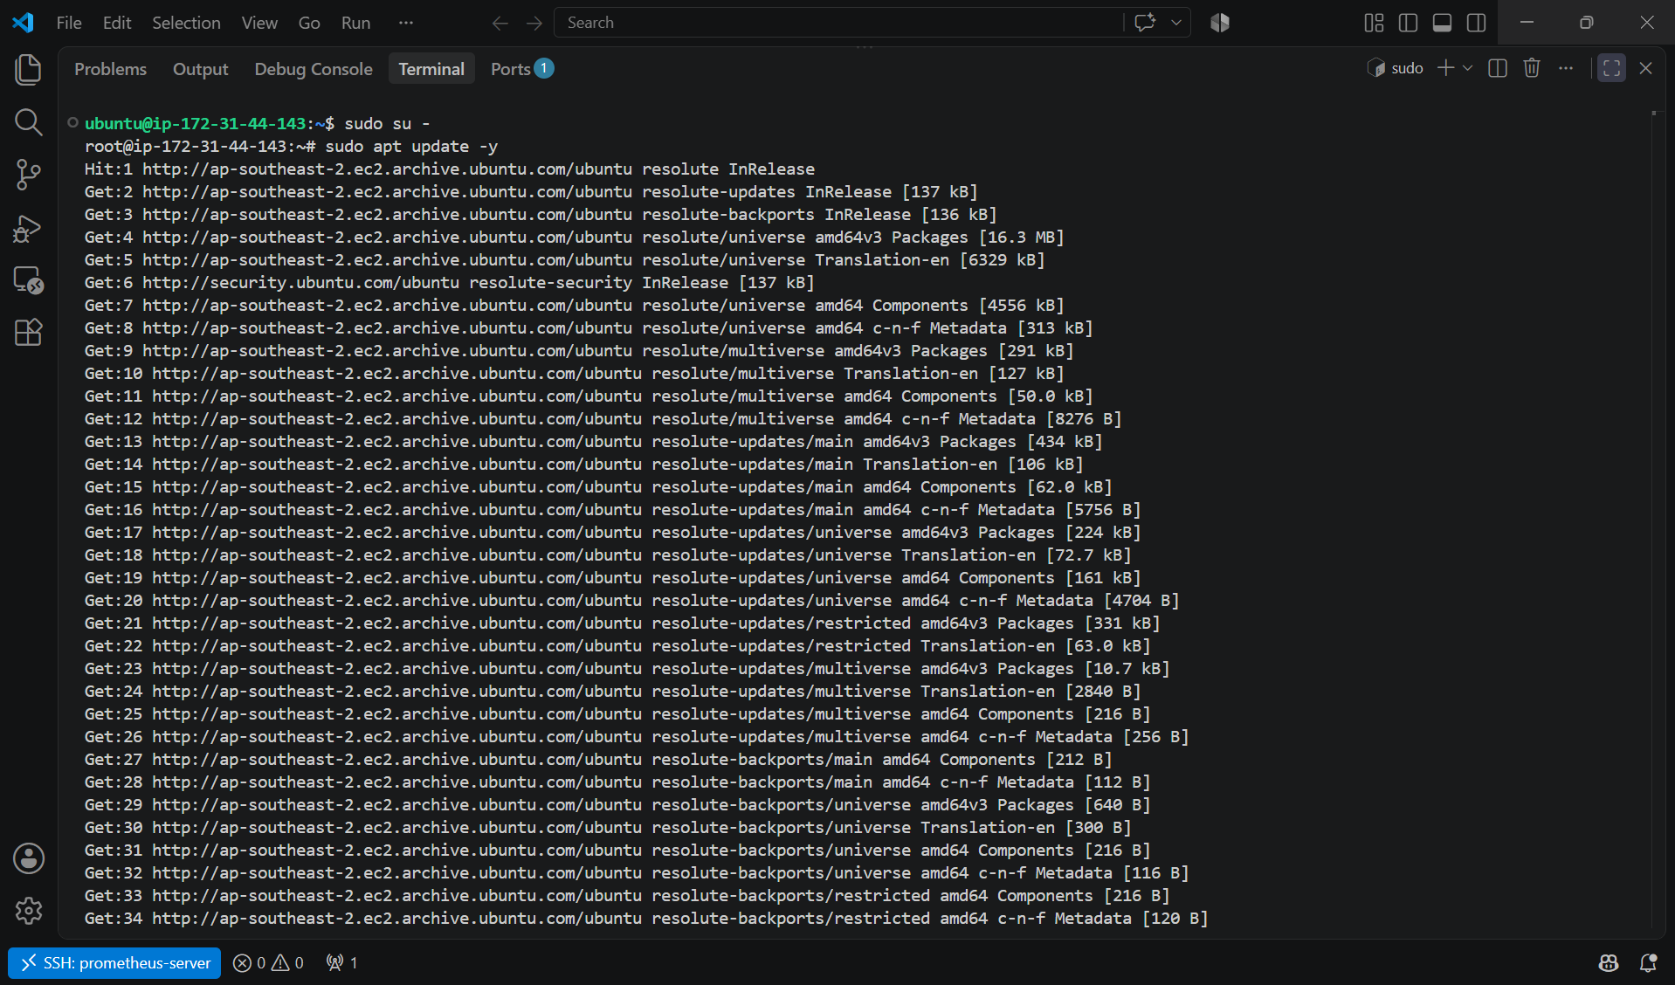

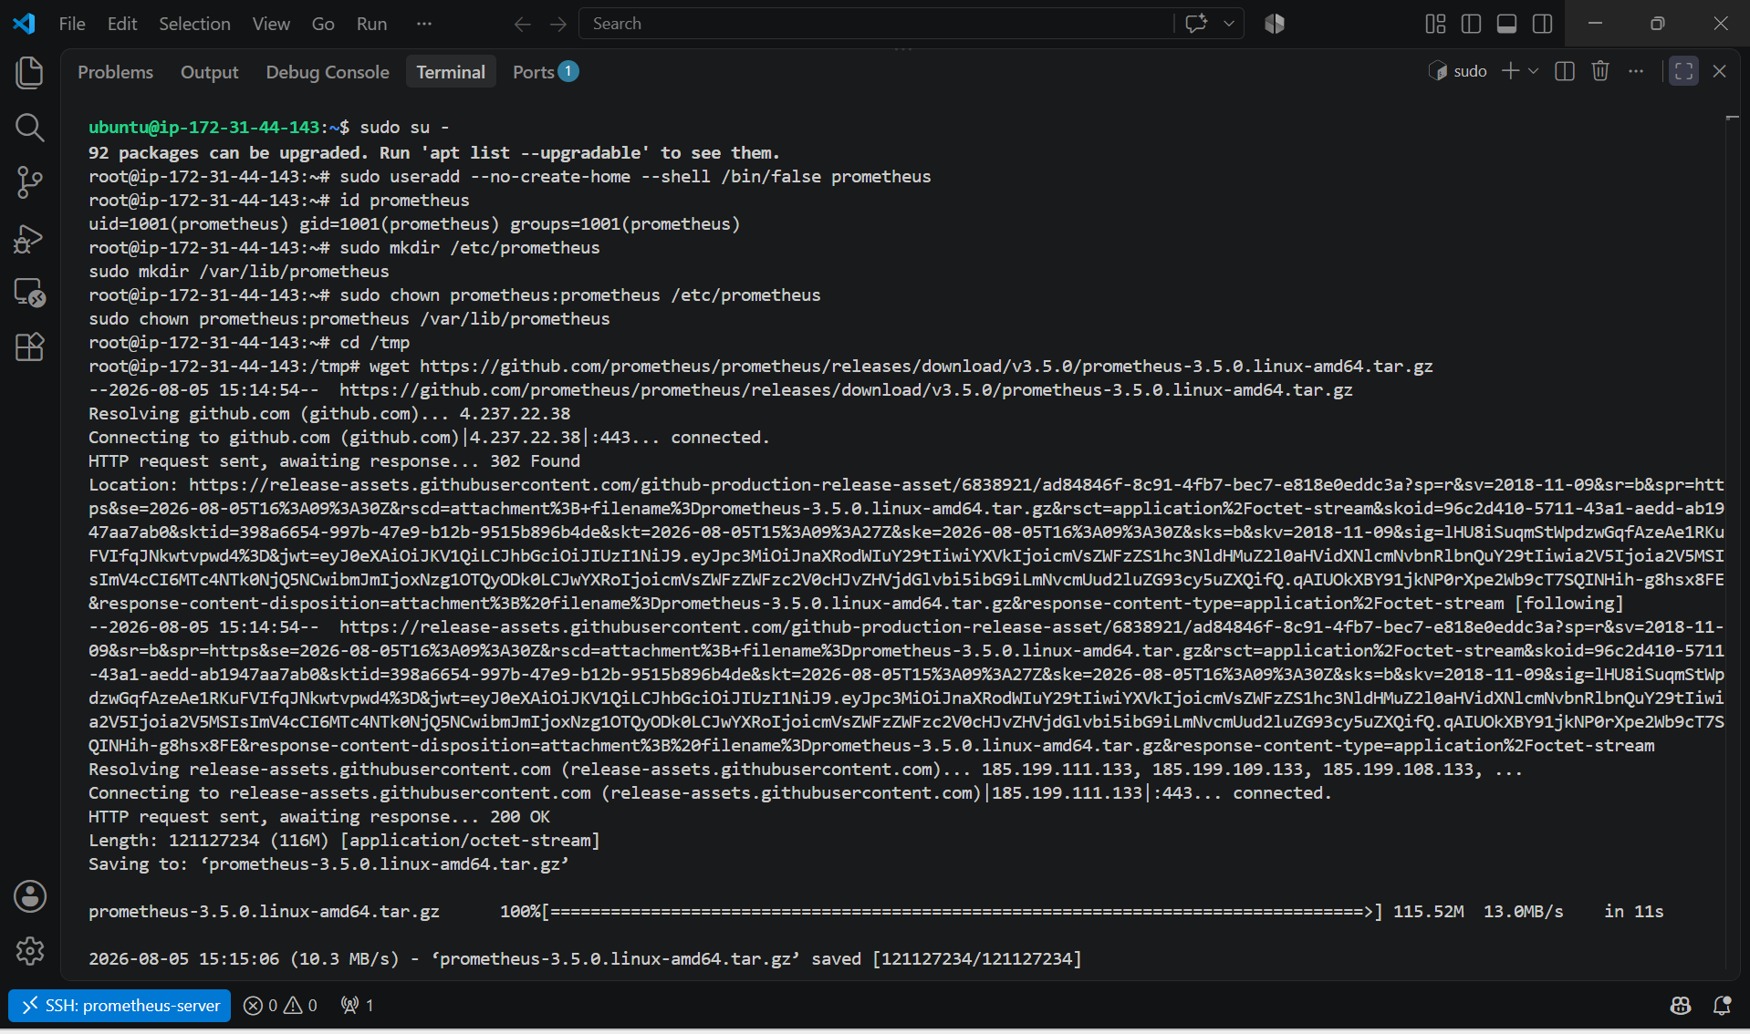

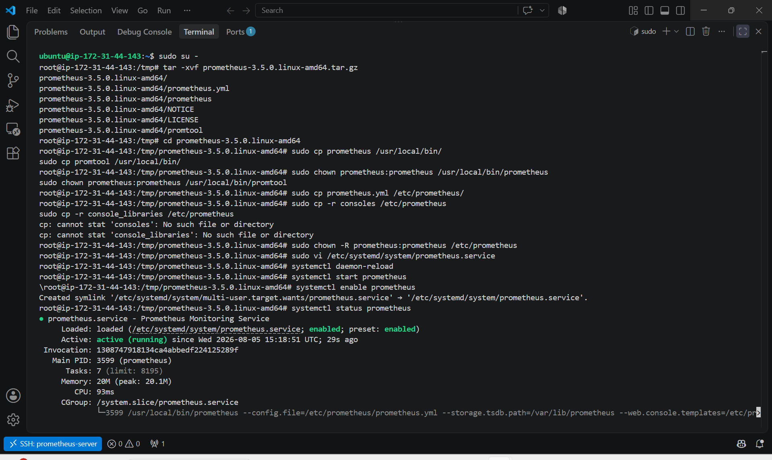

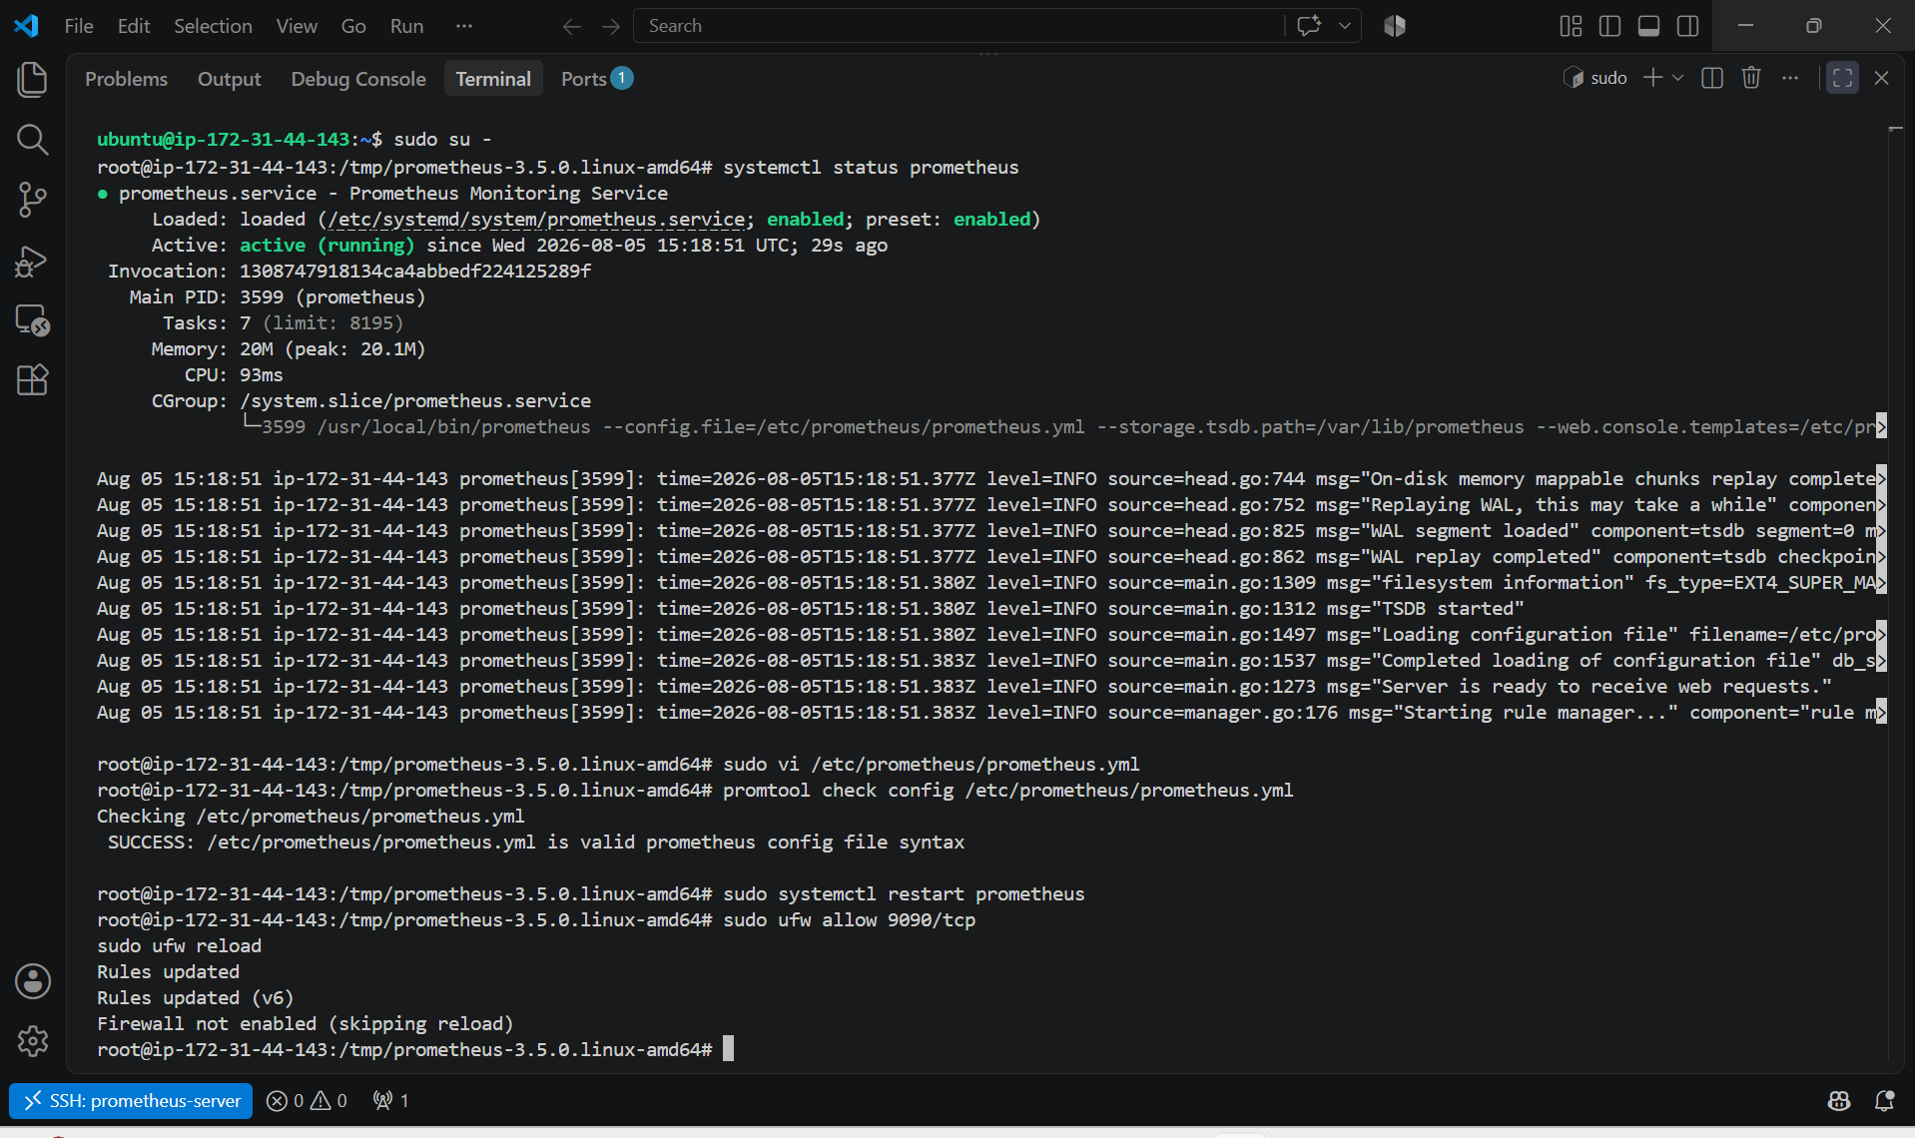

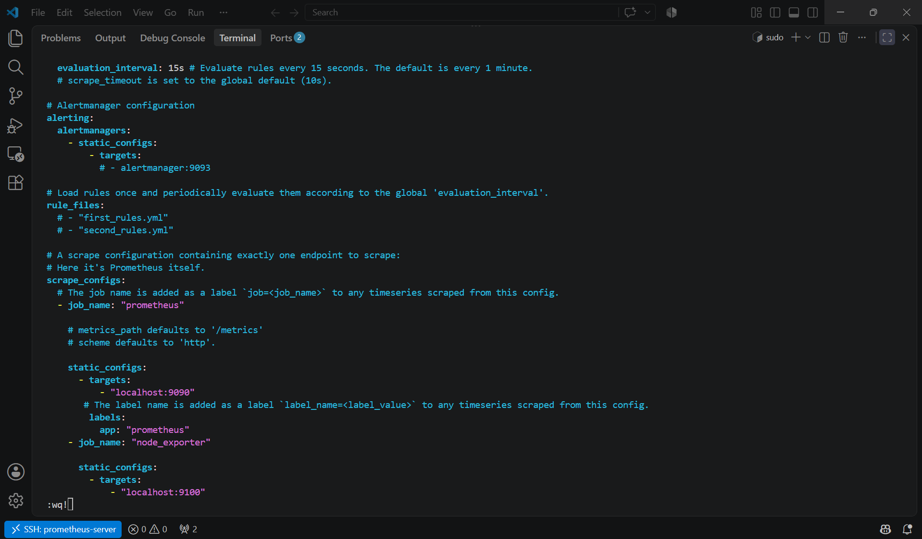

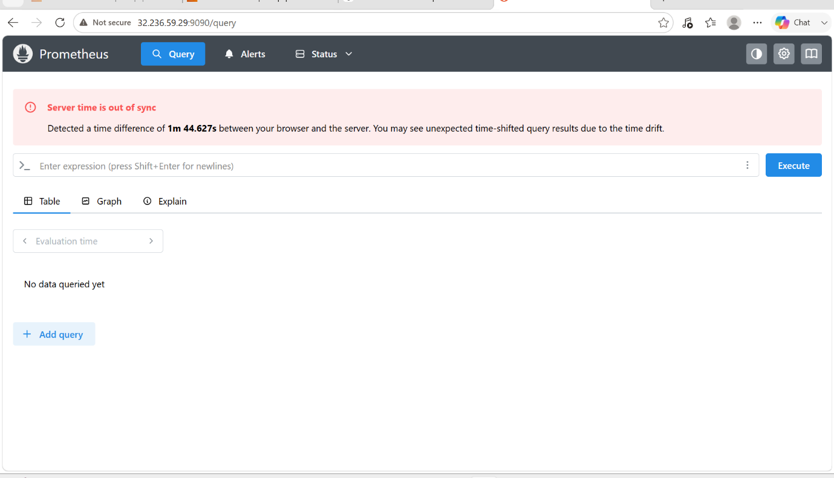

2. Install and configure Node Exporter for system monitoring.

PURPOSE:
- Install Node Exporter on the server.
- Configure it as a system service.
- Expose system metrics on port 9100.
- Configure Prometheus to scrape Node Exporter metrics.
- Verify that the metrics are available in the Prometheus web interface.

OBJECTIVE: To install Node Exporter on a Linux server and configure Prometheus to collect system-level metrics such as CPU, memory, disk, network, and filesystem usage.

ARCHITECTURE:

+----------------------+
| Prometheus |
| Port : 9090 |
+----------+-----------+
|
Scrapes Metrics
|
|
+----------v-----------+
| Node Exporter |
| Port : 9100 |
+----------+-----------+
|
Collects CPU, Memory, Disk,
Network and Filesystem Metrics

PREREQUISITES:
- Ubuntu Server (22.04/24.04)
- Prometheus installed and running
- Internet connection
- Sudo privileges

EXPECTED OUTCOME:
- Node Exporter is installed and running as a system service.
- System metrics are available at http://<SERVER-IP>:9100/metrics.
- Prometheus is configured to scrape Node Exporter.
- The Status → Targets page shows both prometheus and node_exporter with the state UP.
- PromQL queries return real-time system monitoring metrics.

STEP BY STEP IMPLEMENTATION:

Step 1: Update the Server
sudo apt update
sudo apt upgrade -y
Purpose: Updates package repositories and installs the latest security updates.

Step 2: Create Node Exporter User
sudo useradd --no-create-home --shell /bin/false node_exporter
Verify:
id node_exporter
Purpose: Creates a dedicated non-login user for running Node Exporter securely.

Step 3: Download Node Exporter
Move to the temporary directory:
cd /tmp
Download Node Exporter (replace the version if a newer one is available):
wget https://github.com/prometheus/node_exporter/releases/download/v1.9.1/node_exporter-1.9.1.linux-amd64.tar.gz
Extract:
tar -xvf node_exporter-1.9.1.linux-amd64.tar.gz
Go to the extracted directory:
cd node_exporter-1.9.1.linux-amd64
Purpose: Downloads and extracts the Node Exporter binary.

Step 4: Install the Binary
sudo cp node_exporter /usr/local/bin/
Assign ownership:
sudo chown node_exporter:node_exporter /usr/local/bin/node_exporter
Verify:
node_exporter --version
Purpose: Installs the Node Exporter executable in the system path.

Step 5: Create a Systemd Service
Create the service file:
sudo vi /etc/systemd/system/node_exporter.service
Add the following configuration:
[Unit]
Description=Node Exporter
Wants=network-online.target
After=network-online.target

[Service]
User=node_exporter
Group=node_exporter
Type=simple

ExecStart=/usr/local/bin/node_exporter

Restart=always

[Install]
WantedBy=multi-user.target
Save and exit.
Purpose: Configures Node Exporter to run automatically as a background service.

Step 6: Reload Systemd
sudo systemctl daemon-reload
Purpose: Reloads systemd so it recognizes the new service.

Step 7: Enable the Service
sudo systemctl enable node_exporter
Purpose: Ensures Node Exporter starts automatically after a reboot.

Step 8: Start Node Exporter
sudo systemctl start node_exporter
Check the service status:
sudo systemctl status node_exporter
Expected:
Active: active (running)

Step 9: Verify Node Exporter
Check that it is listening on port 9100:
ss -tulnp | grep 9100
Or:
curl http://localhost:9100/metrics
Expected output begins with:
# HELP go_gc_duration_seconds
# TYPE go_gc_duration_seconds summary
Purpose: Confirms that Node Exporter is exposing metrics.

Step 10: Configure Prometheus
Edit the Prometheus configuration:
sudo vi /etc/prometheus/prometheus.yml
Add the following job under scrape_configs:
scrape_configs:

- job_name: "prometheus"
static_configs:
- targets:
- localhost:9090

- job_name: "node_exporter"
static_configs:
- targets:
- localhost:9100
Purpose: Instructs Prometheus to scrape metrics from Node Exporter.

Step 11: Validate the Configuration
promtool check config /etc/prometheus/prometheus.yml
Expected:
SUCCESS: /etc/prometheus/prometheus.yml is valid

Step 12: Restart Prometheus
sudo systemctl restart prometheus
Verify:
sudo systemctl status prometheus

Step 13: Allow Firewall (Optional)
sudo ufw allow 9100/tcp
sudo ufw reload
Purpose: Allows access to Node Exporter from Prometheus if it is running on another server.

Step 14: Verify in Prometheus
Open:
http://<SERVER-IP>:9090
Go to:
Status → Targets
Expected:
Job | Endpoint | State
prometheus | localhost:9090 | UP
node_exporter | localhost:9100 | UP

Step 15: Test Metrics
In the Prometheus Query page, execute:
up
Expected:
up{job="prometheus",instance="localhost:9090"} 1
up{job="node_exporter",instance="localhost:9100"} 1
Other useful queries:
node_cpu_seconds_total
node_memory_MemAvailable_bytes
node_filesystem_avail_bytes
node_network_receive_bytes_total
These queries display CPU, memory, disk, and network metrics collected by Node Exporter.

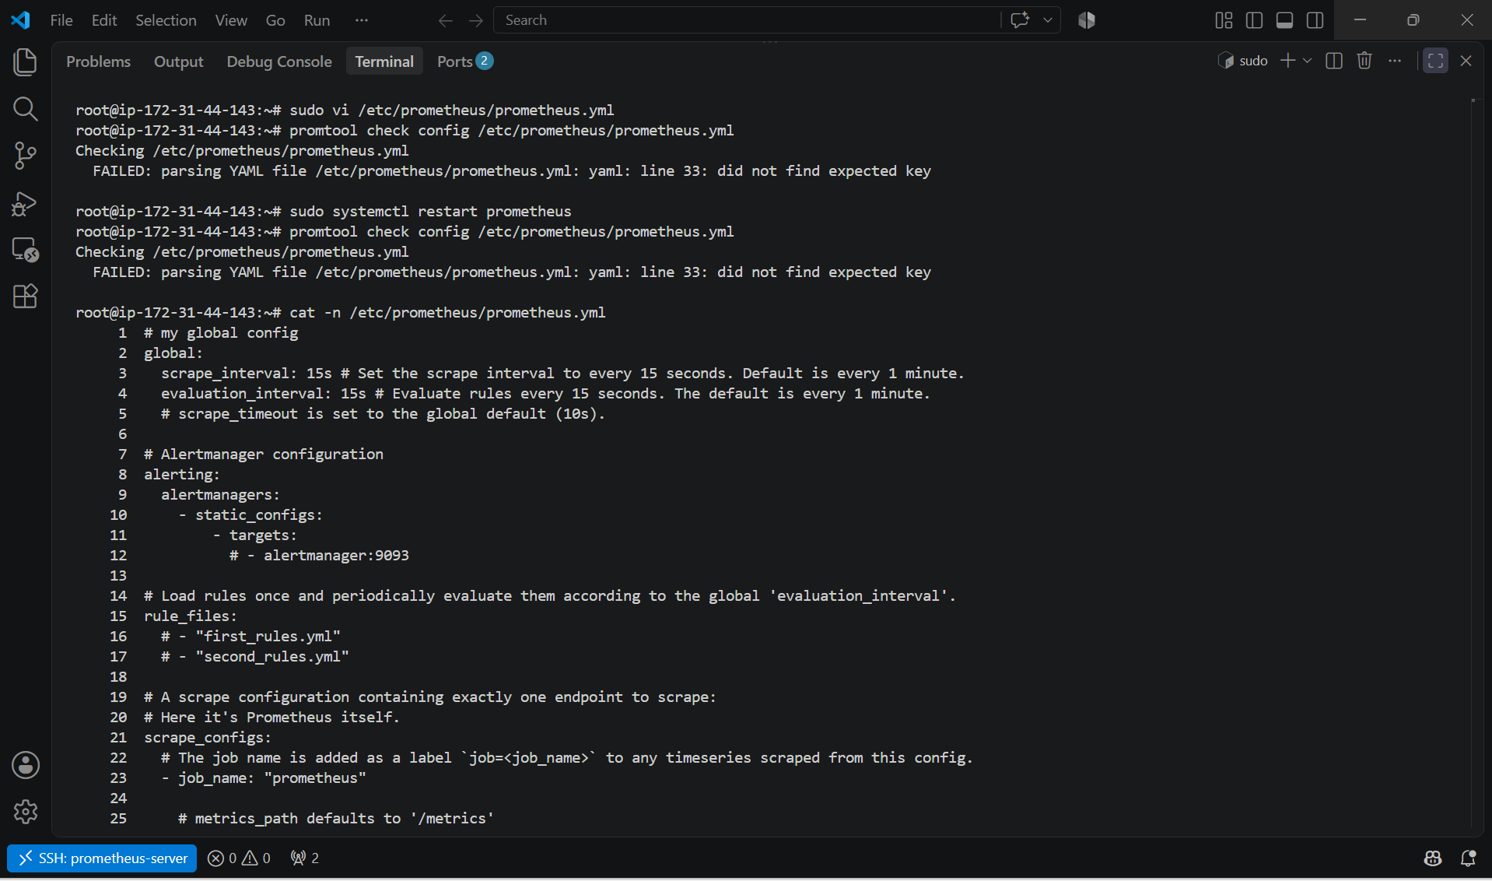

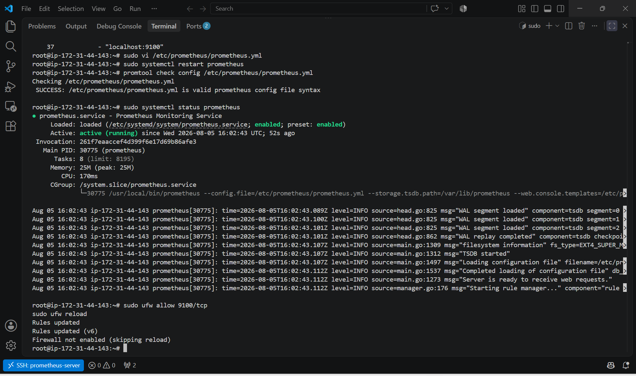

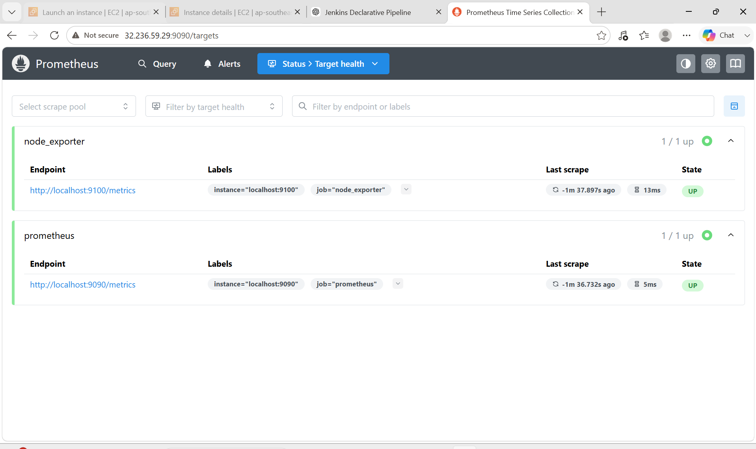

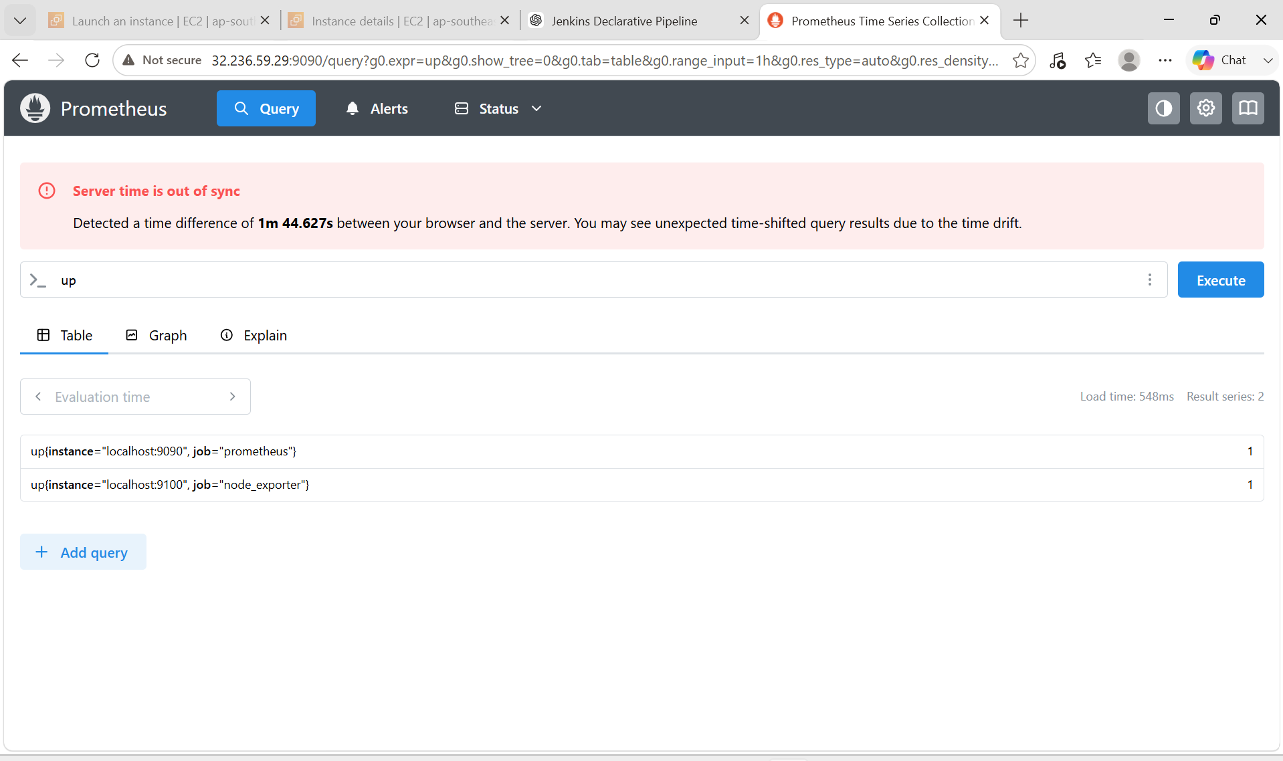

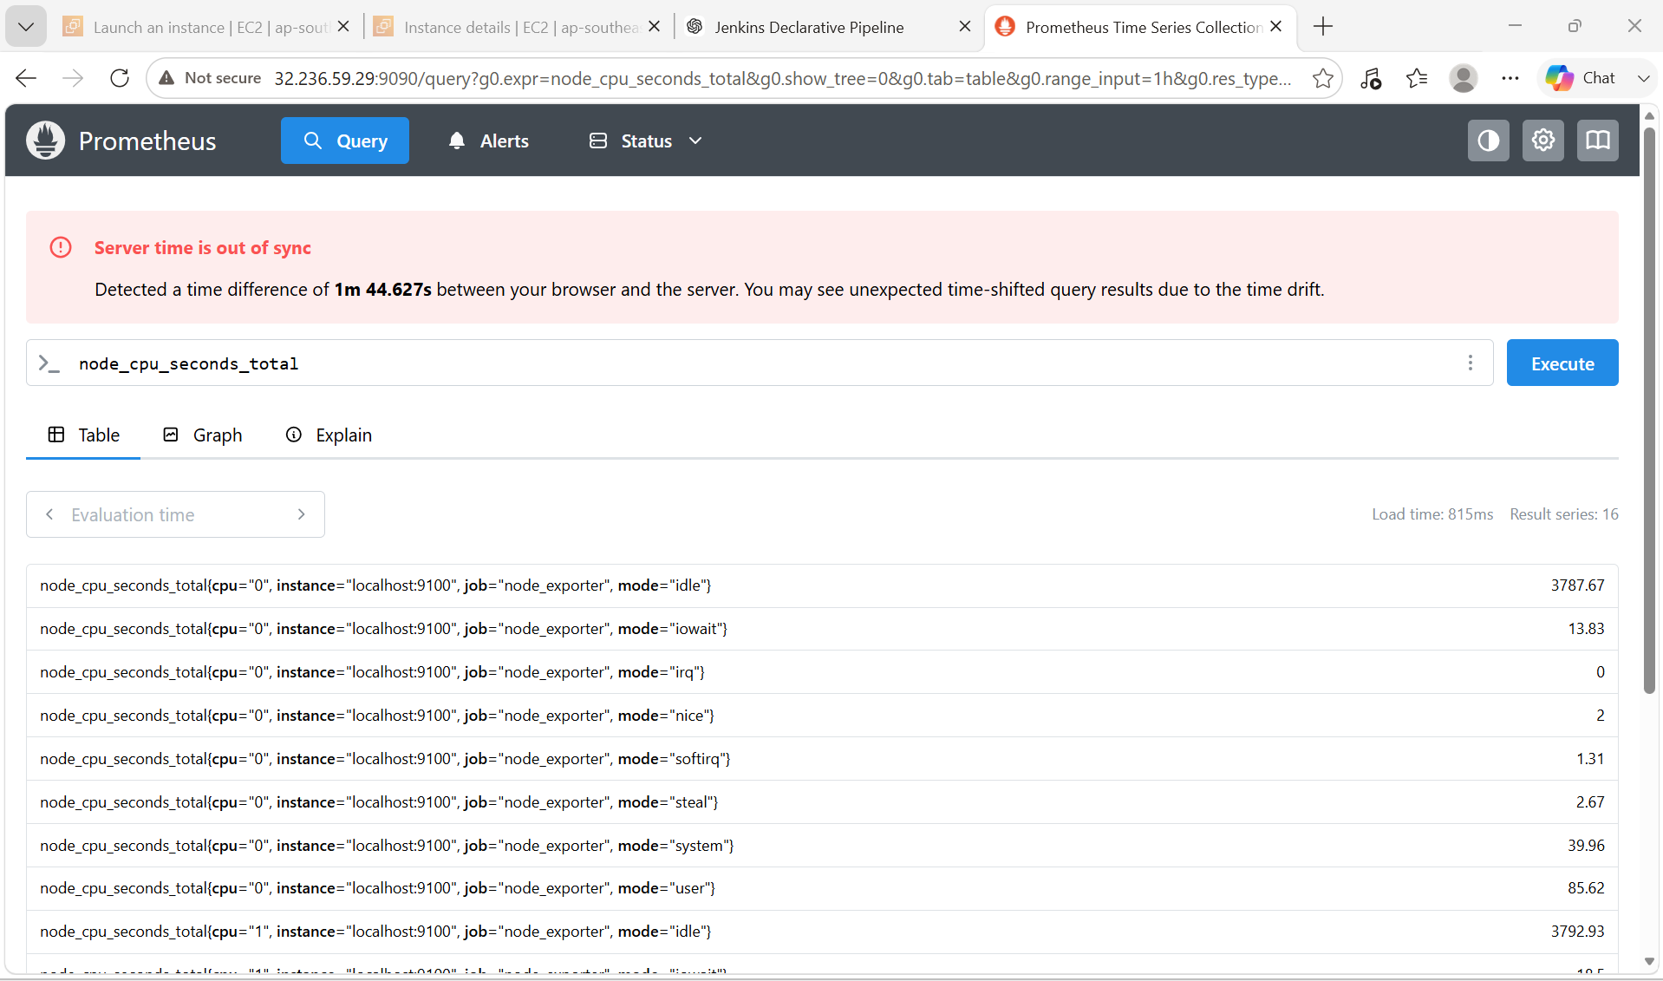

3. Set up SNMP Exporter to monitor network devices.

PURPOSE:
- Install SNMP Exporter on the monitoring server.
- Configure SNMP Exporter as a system service.
- Enable SNMP on network devices.
- Configure Prometheus to scrape SNMP Exporter.
- Monitor routers, switches, firewalls, and printers using SNMP.
- Verify collected metrics in Prometheus.

OBJECTIVE: To install SNMP Exporter, configure it to collect SNMP metrics from network devices (such as routers, switches, and firewalls), integrate it with Prometheus, and verify that the metrics are successfully collected.

ARCHITECTURE:

+-----------------------+
| Prometheus |
| Port : 9090 |
+-----------+-----------+
|
Scrapes Metrics
|
|
+-----------v-----------+
| SNMP Exporter |
| Port : 9116 |
+-----------+-----------+
|
SNMP Queries (UDP 161)
|
-------------------------------------------
| | |
Router Switch Firewall

PREREQUISITES:
- Ubuntu 22.04/24.04 Server
- Prometheus installed
- Sudo privileges
- SNMP enabled on network devices
- Network connectivity to devices on UDP port 161

EXPECTED OUTCOME:
- SNMP Exporter is installed and running as a system service on port 9116.
- Network devices respond to SNMP requests on UDP port 161.
- Prometheus scrapes metrics through SNMP Exporter.
- The Status → Targets page shows the snmp job with the status UP.
- PromQL queries return interface, traffic, and uptime metrics for monitored network devices.

STEP BY STEP IMPLEMENTATION:

Step 1: Update the Server
sudo apt update
sudo apt upgrade -y
Purpose: Updates the package index and installs the latest security patches.

Step 2: Create SNMP Exporter User
sudo useradd --no-create-home --shell /bin/false snmp_exporter
Verify:
id snmp_exporter
Purpose: Creates a dedicated non-login user to securely run SNMP Exporter.

Step 3: Download SNMP Exporter
cd /tmp
Download the latest release (replace the version if needed):
wget https://github.com/prometheus/snmp_exporter/releases/download/v0.29.0/snmp_exporter-0.29.0.linux-amd64.tar.gz
Extract:
tar -xvf snmp_exporter-0.29.0.linux-amd64.tar.gz
Move into the directory:
cd snmp_exporter-0.29.0.linux-amd64
Purpose: Downloads and extracts the SNMP Exporter binaries and configuration.

Step 4: Install SNMP Exporter
Copy the binary:
sudo cp snmp_exporter /usr/local/bin/
Create the configuration directory:
sudo mkdir -p /etc/snmp_exporter
Copy the configuration file:
sudo cp snmp.yml /etc/snmp_exporter/
Assign ownership:
sudo chown -R snmp_exporter:snmp_exporter /etc/snmp_exporter
sudo chown snmp_exporter:snmp_exporter /usr/local/bin/snmp_exporter
Purpose: Installs the executable and default SNMP configuration.

Step 5: Create a Systemd Service
Create the service file:
sudo vi /etc/systemd/system/snmp_exporter.service
Add:
[Unit]
Description=SNMP Exporter
Wants=network-online.target
After=network-online.target

[Service]
User=snmp_exporter
Group=snmp_exporter
Type=simple

ExecStart=/usr/local/bin/snmp_exporter \
--config.file=/etc/snmp_exporter/snmp.yml

Restart=always

[Install]
WantedBy=multi-user.target
Purpose: Runs SNMP Exporter as a background service.

Step 6: Start the Service
Reload systemd:
sudo systemctl daemon-reload
Enable the service:
sudo systemctl enable snmp_exporter
Start the service:
sudo systemctl start snmp_exporter
Verify:
sudo systemctl status snmp_exporter
Expected:
Active: active (running)

Step 7: Verify SNMP Exporter
Check the listening port:
ss -tulnp | grep 9116
Or test:
curl http://localhost:9116
Purpose: Confirms SNMP Exporter is running and serving metrics.

Step 8: Configure Prometheus
Edit:
sudo vi /etc/prometheus/prometheus.yml
Add the following under scrape_configs:
- job_name: "snmp"

metrics_path: /snmp

params:
module: [if_mib]

static_configs:
- targets:
- 192.168.1.1

relabel_configs:
- source_labels: [__address__]
target_label: __param_target

- source_labels: [__param_target]
target_label: instance

- target_label: __address__
replacement: localhost:9116
Replace 192.168.1.1 with the IP address of your router, switch, or firewall.
Purpose: Configures Prometheus to request SNMP metrics from the exporter instead of polling devices directly.

Step 9: Validate Configuration
promtool check config /etc/prometheus/prometheus.yml
Expected:
SUCCESS: /etc/prometheus/prometheus.yml is valid

Step 10: Restart Prometheus
sudo systemctl restart prometheus
Verify:
sudo systemctl status prometheus

Step 11: Allow Firewall (Optional)
sudo ufw allow 9116/tcp
sudo ufw reload
Purpose: Allows Prometheus to reach the SNMP Exporter if it runs on another server.

Step 12: Enable SNMP on the Network Device
Example (Cisco IOS):
conf t
snmp-server community public RO
snmp-server location DataCenter
snmp-server contact admin@example.com
end
write memory
Replace public with a secure, read-only community string in production environments.

Step 13: Verify in Prometheus
Open:
http://<SERVER-IP>:9090
Go to:
Status → Targets
Expected:
Job | Endpoint | State
prometheus | localhost:9090 | UP
node_exporter | localhost:9100 | UP
snmp | localhost:9116 | UP

Step 14: Test SNMP Metrics
In the Prometheus Query page, execute:
up
Expected:
up{job="snmp"} 1
Other useful queries:
ifInOctets
ifOutOctets
ifOperStatus
sysUpTime
These metrics can be used to monitor interface traffic, interface status, and device uptime.

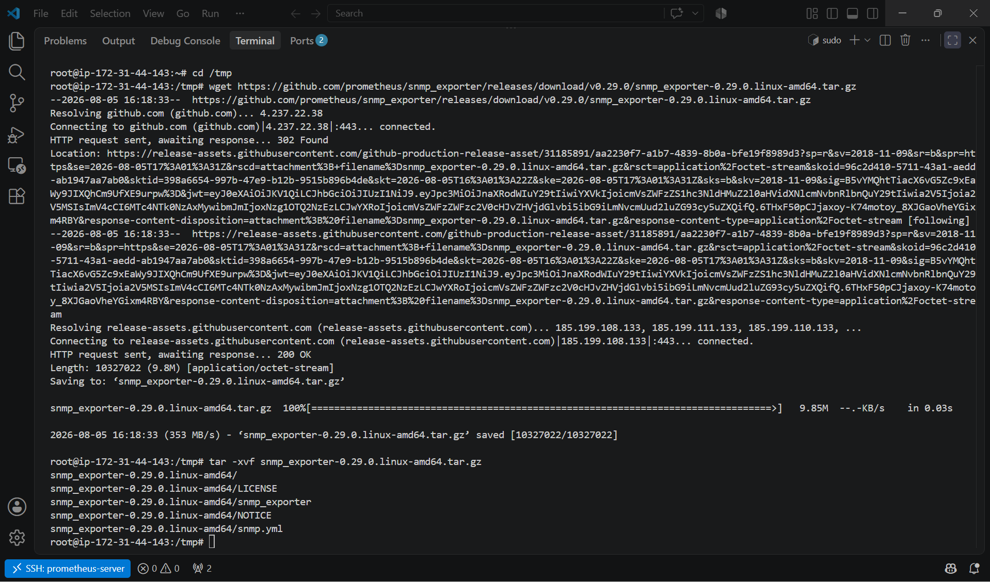

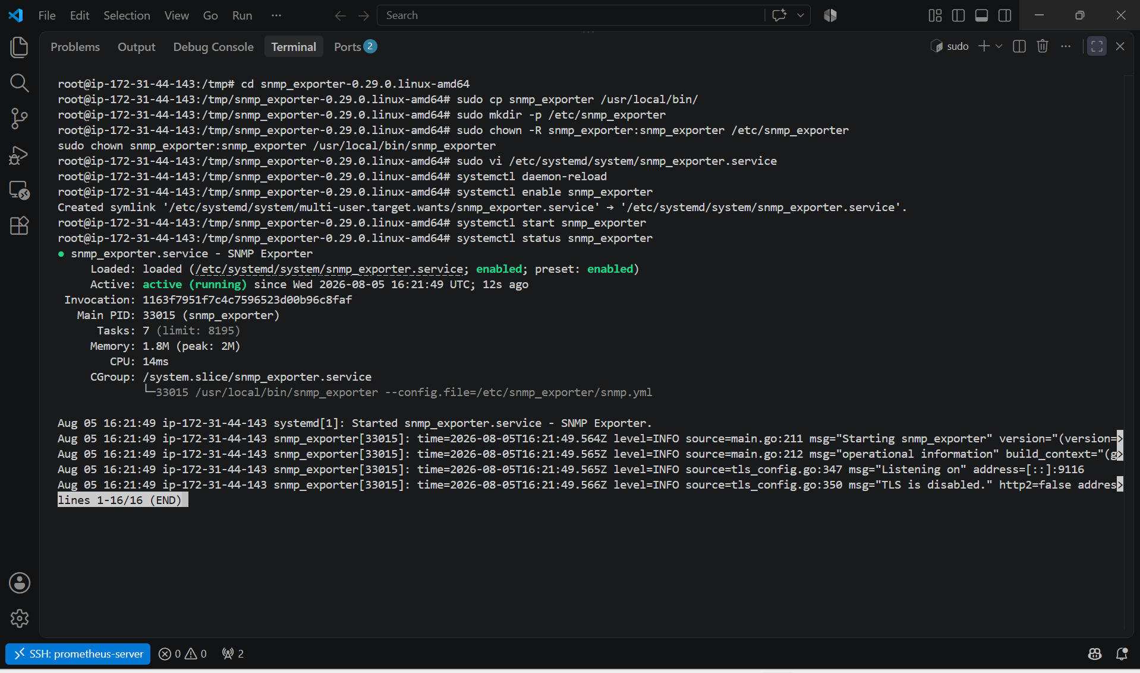

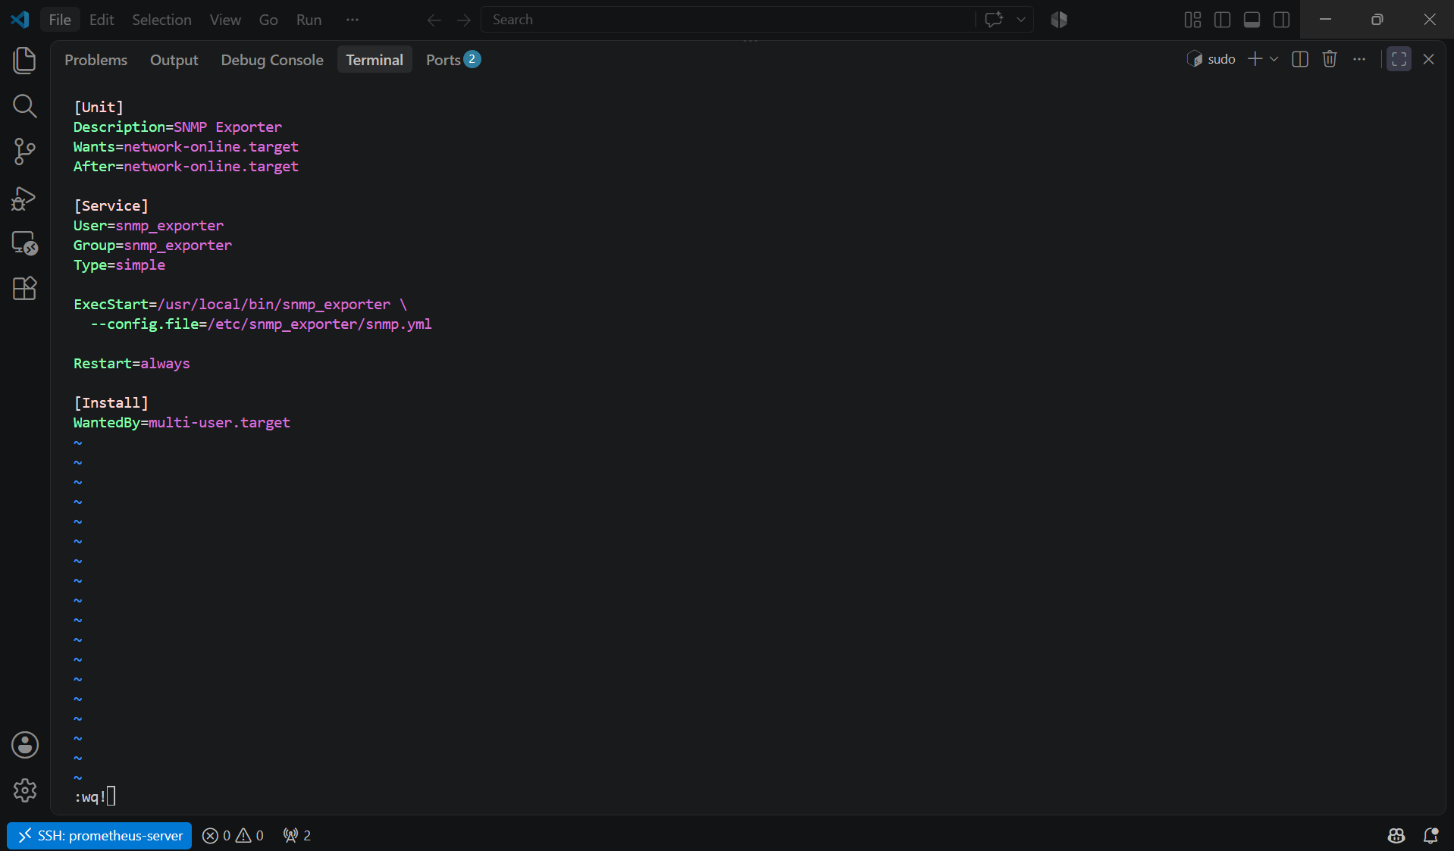

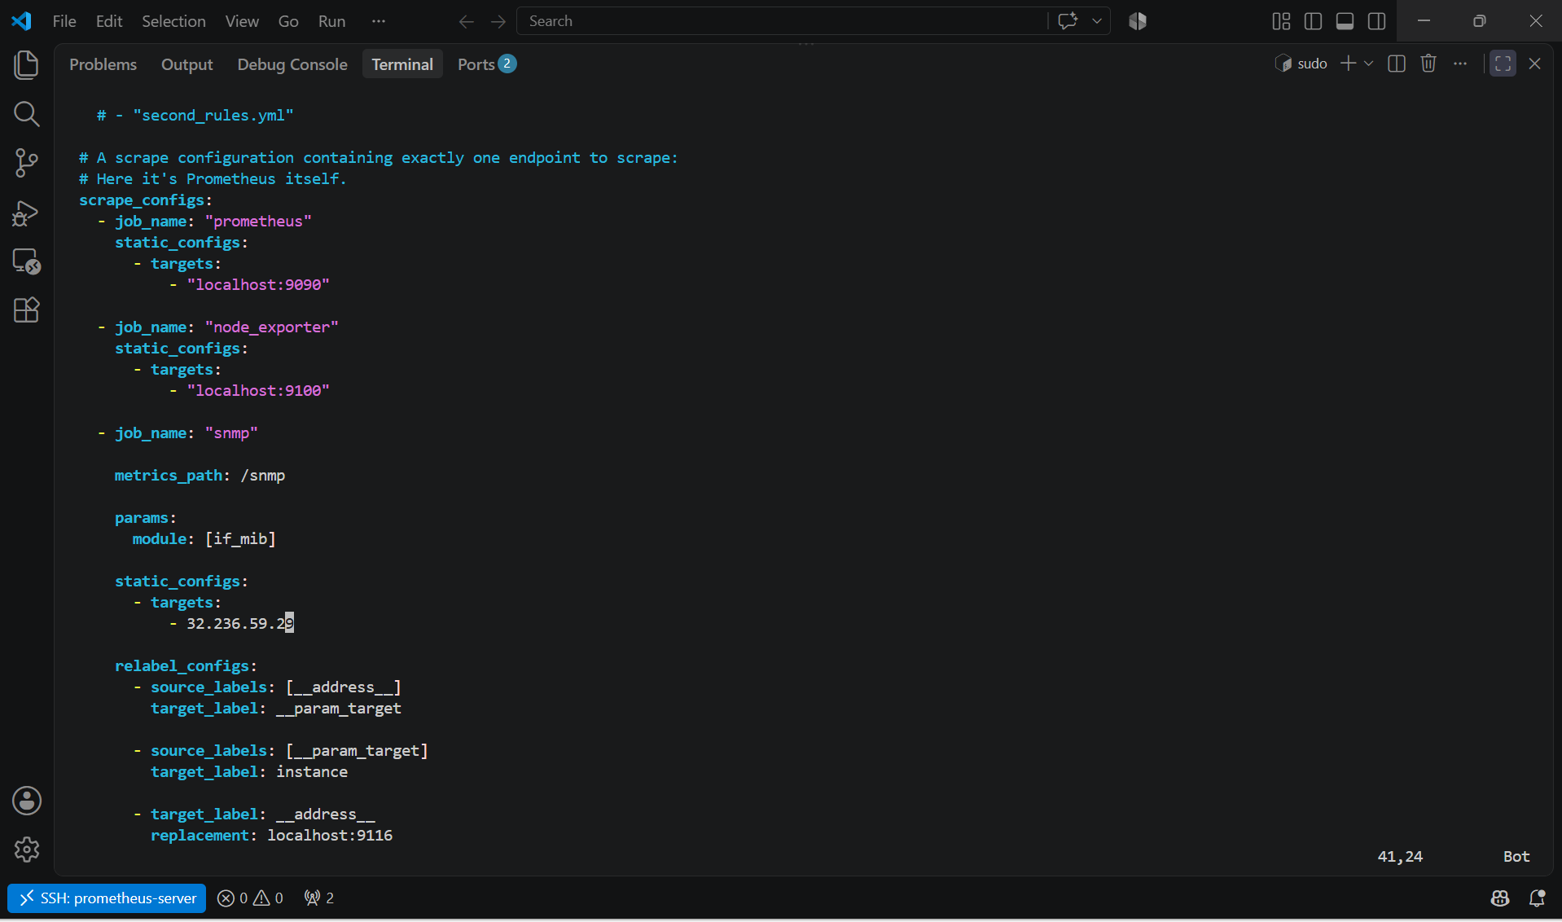

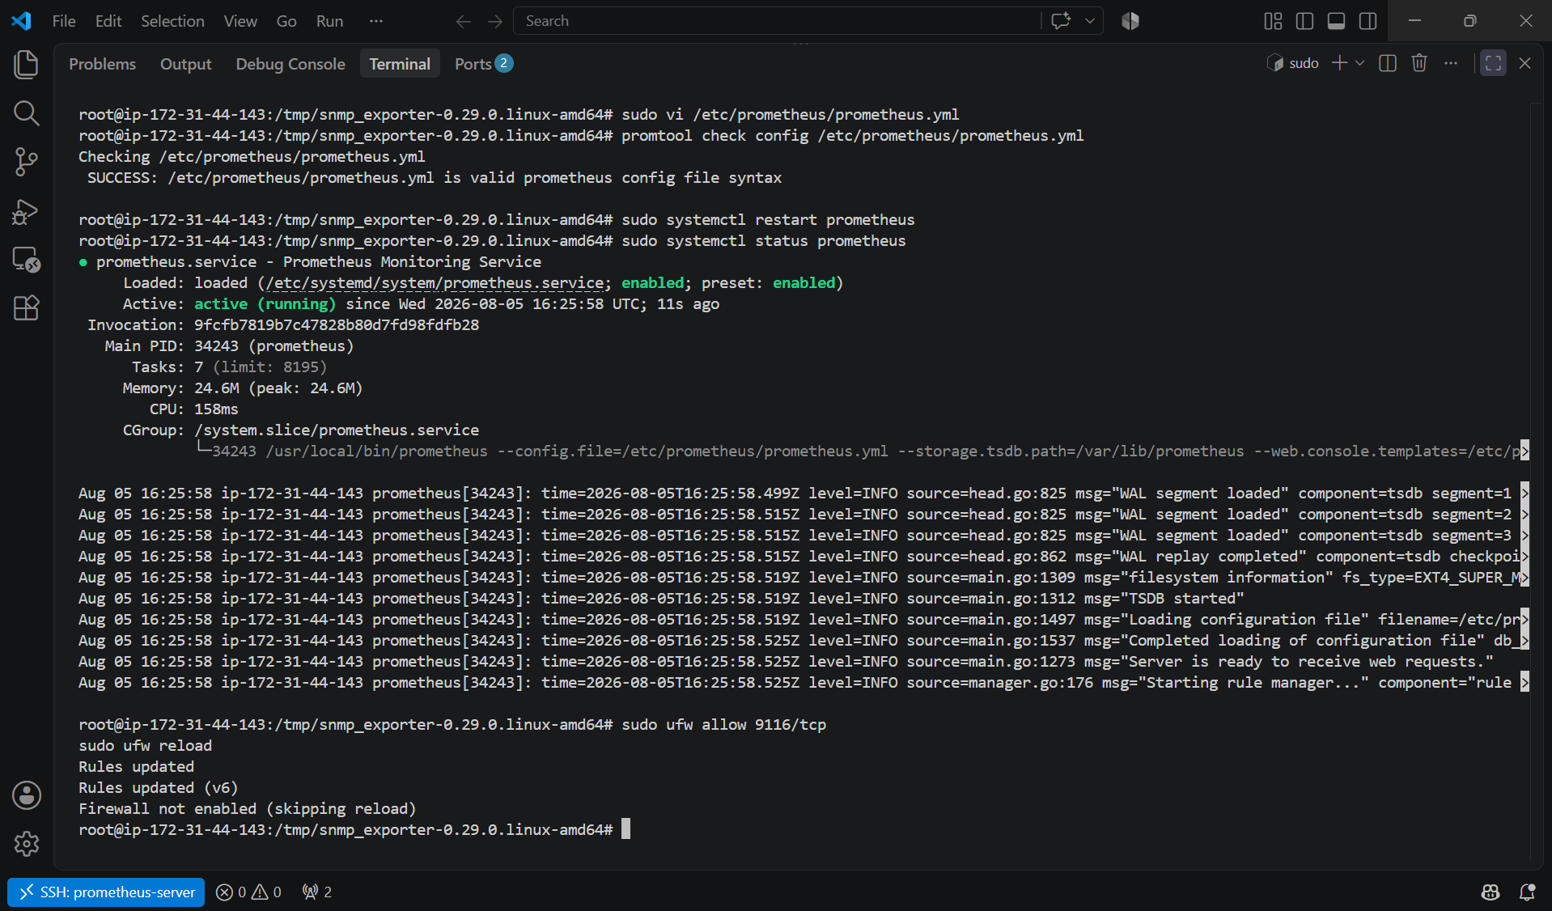

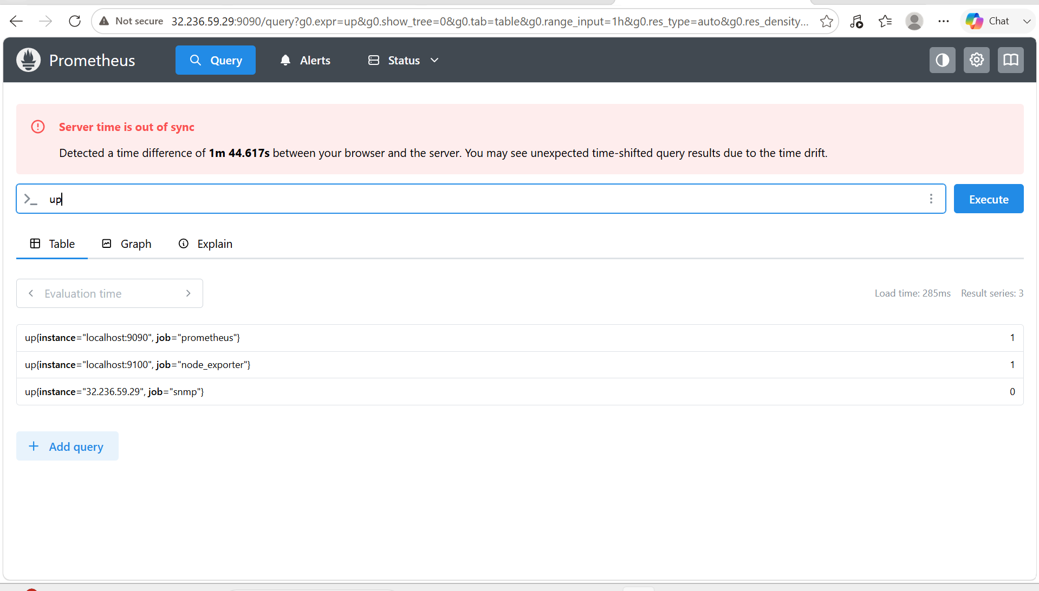

4. Set up Prometheus to run as a systemd service for automatic startup.

PURPOSE:
- Run Prometheus as a background service.
- Automatically start Prometheus after every server reboot.
- Manage the service using systemctl.
- Improve reliability and simplify administration.

OBJECTIVE: To configure Prometheus as a systemd service so that it starts automatically when the Linux server boots and can be managed using systemctl.

EXPECTED OUTCOME:
- Prometheus is running as a systemd service.
- The service starts automatically after every server reboot.
- Prometheus listens on port 9090.
- The service can be managed with systemctl.
- Monitoring continues automatically without manual intervention after restarts.

STEP BY STEP IMPLEMENTATION:

Step 1: Create a Prometheus User
sudo useradd --no-create-home --shell /bin/false prometheus
Verify:
id prometheus
Purpose: Creates a dedicated, non-login user to run the Prometheus service securely.

Step 2: Create Required Directories
sudo mkdir -p /etc/prometheus
sudo mkdir -p /var/lib/prometheus
Assign ownership:
sudo chown -R prometheus:prometheus /etc/prometheus
sudo chown -R prometheus:prometheus /var/lib/prometheus
Purpose: Stores the Prometheus configuration and time-series database with the correct permissions.

Step 3: Create the Systemd Service File
Create the service file:
sudo vi /etc/systemd/system/prometheus.service
Add the following configuration:
[Unit]
Description=Prometheus Monitoring Service
Documentation=https://prometheus.io/docs/introduction/overview/
Wants=network-online.target
After=network-online.target

[Service]
User=prometheus
Group=prometheus
Type=simple

ExecStart=/usr/local/bin/prometheus \
--config.file=/etc/prometheus/prometheus.yml \
--storage.tsdb.path=/var/lib/prometheus \
--web.console.templates=/etc/prometheus/consoles \
--web.console.libraries=/etc/prometheus/console_libraries

Restart=always
RestartSec=5

[Install]
WantedBy=multi-user.target
Purpose: Defines how Prometheus should be started, restarted, and managed by systemd.

Step 4: Reload Systemd
sudo systemctl daemon-reload
Purpose: Reloads the systemd manager configuration so it recognizes the new service.

Step 5: Enable Prometheus
sudo systemctl enable prometheus
Expected output:
Created symlink /etc/systemd/system/multi-user.target.wants/prometheus.service → /etc/systemd/system/prometheus.service
Purpose: Configures Prometheus to start automatically at system boot.

Step 6: Start the Service
sudo systemctl start prometheus
Purpose: Starts the Prometheus service immediately.

Step 7: Verify the Service
Check the service status:
sudo systemctl status prometheus
Expected:
● prometheus.service - Prometheus Monitoring Service
Loaded: loaded (/etc/systemd/system/prometheus.service)
Active: active (running)

Step 8: Check if Prometheus is Listening
ss -tulnp | grep 9090
Expected:
LISTEN 0 4096 *:9090
Purpose: Confirms that Prometheus is listening on port 9090.

Step 9: Verify Automatic Startup
Check whether the service is enabled:
systemctl is-enabled prometheus
Expected:
enabled

Step 10: Test After Reboot
Reboot the server:
sudo reboot
After reconnecting:
sudo systemctl status prometheus
Expected:
Active: active (running)

Useful Service Management Commands
Start Prometheus:
sudo systemctl start prometheus
Stop Prometheus:
sudo systemctl stop prometheus
Restart Prometheus:
sudo systemctl restart prometheus
Reload configuration (after editing prometheus.yml):
sudo systemctl restart prometheus
Check status:
sudo systemctl status prometheus
View recent logs:
sudo journalctl -u prometheus -n 50 --no-pager
Follow logs in real time:
sudo journalctl -u prometheus -f

Verification
Open the Prometheus web interface:
http://<SERVER-IP>:9090
Navigate to Status → Targets and confirm the configured targets (such as prometheus and node_exporter) show the state UP.

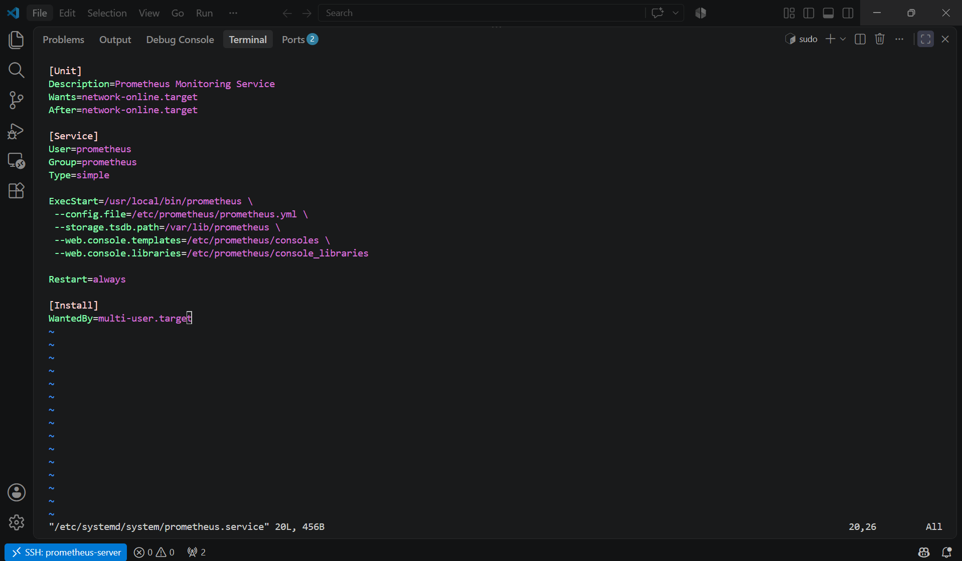

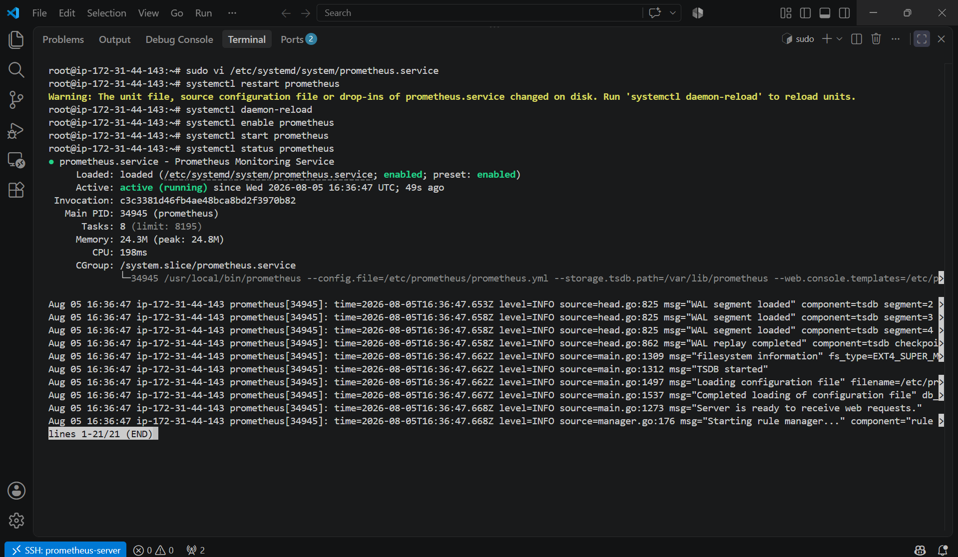

5. Install Alertmanager and configure an email alert.

OBJECTIVE: To install Prometheus Alertmanager, configure it as a system service, integrate it with Prometheus, and send email notifications when an alert is triggered.

PURPOSE:
- Install Alertmanager.
- Configure email notifications using SMTP.
- Integrate Alertmanager with Prometheus.
- Create an alert rule.
- Verify that email alerts are delivered.

ARCHITECTURE:

+--------------------+
| Prometheus |
| Port 9090 |
+---------+----------+
|
Sends Alerts
|
+---------v----------+
| Alertmanager |
| Port 9093 |
+---------+----------+
|
SMTP Server
|
+---------v----------+
| Email |
+--------------------+

EXPECTED OUTCOME:
- Alertmanager is installed and running as a systemd service.
- Prometheus forwards alerts to Alertmanager.
- Alertmanager sends email notifications through the configured SMTP server.
- Alerts appear in both the Prometheus and Alertmanager web interfaces.
- Email notifications are received when the alert condition is triggered and again when it is resolved.

STEP BY STEP IMPLEMENTATION:

Step 1: Create Alertmanager User
sudo useradd --no-create-home --shell /bin/false alertmanager
Verify:
id alertmanager

Step 2: Create Required Directories
sudo mkdir -p /etc/alertmanager
sudo mkdir -p /var/lib/alertmanager
Assign ownership:
sudo chown -R alertmanager:alertmanager /etc/alertmanager
sudo chown -R alertmanager:alertmanager /var/lib/alertmanager

Step 3: Download Alertmanager
cd /tmp
Download the latest release (replace the version if needed):
wget https://github.com/prometheus/alertmanager/releases/download/v0.28.1/alertmanager-0.28.1.linux-amd64.tar.gz
Extract:
tar -xvf alertmanager-0.28.1.linux-amd64.tar.gz
Enter the directory:
cd alertmanager-0.28.1.linux-amd64

Step 4: Install Alertmanager
Copy binaries:
sudo cp alertmanager /usr/local/bin/
sudo cp amtool /usr/local/bin/
Copy configuration:
sudo cp alertmanager.yml /etc/alertmanager/
Assign permissions:
sudo chown alertmanager:alertmanager /usr/local/bin/alertmanager
sudo chown alertmanager:alertmanager /usr/local/bin/amtool
sudo chown -R alertmanager:alertmanager /etc/alertmanager

Step 5: Create Systemd Service
sudo vi /etc/systemd/system/alertmanager.service
Paste:
[Unit]
Description=Alertmanager
Wants=network-online.target
After=network-online.target

[Service]
User=alertmanager
Group=alertmanager
Type=simple

ExecStart=/usr/local/bin/alertmanager \
--config.file=/etc/alertmanager/alertmanager.yml \
--storage.path=/var/lib/alertmanager

Restart=always

[Install]
WantedBy=multi-user.target

Step 6: Reload and Start
sudo systemctl daemon-reload

sudo systemctl enable alertmanager

sudo systemctl start alertmanager
Verify:
sudo systemctl status alertmanager

Step 7: Configure Email
Edit:
sudo vi /etc/alertmanager/alertmanager.yml
Example configuration (Gmail SMTP):
global:
smtp_smarthost: 'smtp.gmail.com:587'
smtp_from: 'your_email@gmail.com'
smtp_auth_username: 'your_email@gmail.com'
smtp_auth_password: 'YOUR_GMAIL_APP_PASSWORD'
smtp_require_tls: true

route:
receiver: email-alert

receivers:
- name: email-alert
email_configs:
- to: 'receiver@gmail.com'
send_resolved: true
Note: If you use Gmail with two-factor authentication, create a Google App Password and use it for smtp_auth_password. Your normal Gmail password will not work.

Step 8: Validate Configuration
amtool check-config /etc/alertmanager/alertmanager.yml
Expected:
SUCCESS

Step 9: Restart Alertmanager
sudo systemctl restart alertmanager

Step 10: Configure Prometheus
Edit:
sudo vi /etc/prometheus/prometheus.yml
Add:
alerting:
alertmanagers:
- static_configs:
- targets:
- localhost:9093

rule_files:
- "alert.rules.yml"

Step 11: Create Alert Rules
sudo vi /etc/prometheus/alert.rules.yml
Example:
groups:
- name: server-alerts

rules:

- alert: InstanceDown

expr: up == 0

for: 1m

labels:
severity: critical

annotations:
summary: "Server Down"

description: "The monitored target is unreachable."

Step 12: Validate Prometheus Configuration
promtool check config /etc/prometheus/prometheus.yml

promtool check rules /etc/prometheus/alert.rules.yml
Expected:
SUCCESS

Step 13: Restart Prometheus
sudo systemctl restart prometheus

Step 14: Verify Alertmanager
Check:
ss -tulnp | grep 9093
Expected:
LISTEN 0 4096 *:9093
Open:
http://<SERVER-IP>:9093

Step 15: Test the Alert
Stop Node Exporter:
sudo systemctl stop node_exporter
After approximately 1 minute, the InstanceDown alert should fire and an email should be sent.
Restart Node Exporter:
sudo systemctl start node_exporter
Because send_resolved: true is configured, a resolution email will also be sent.

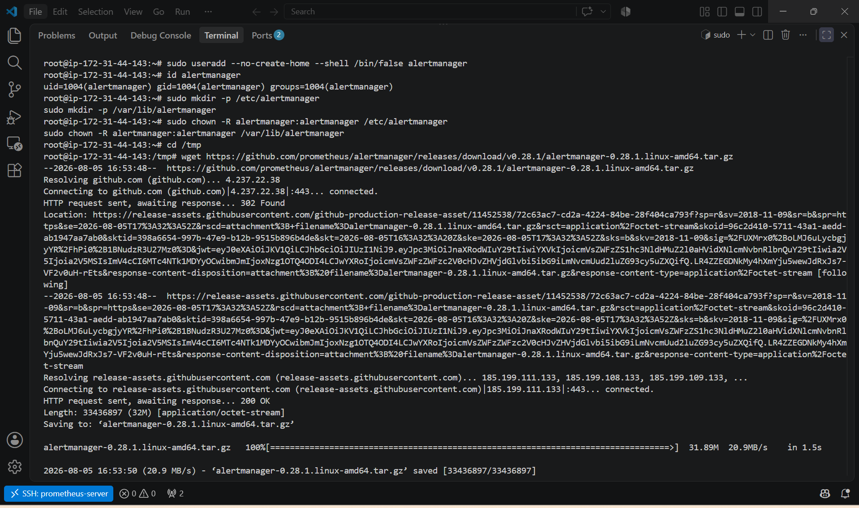

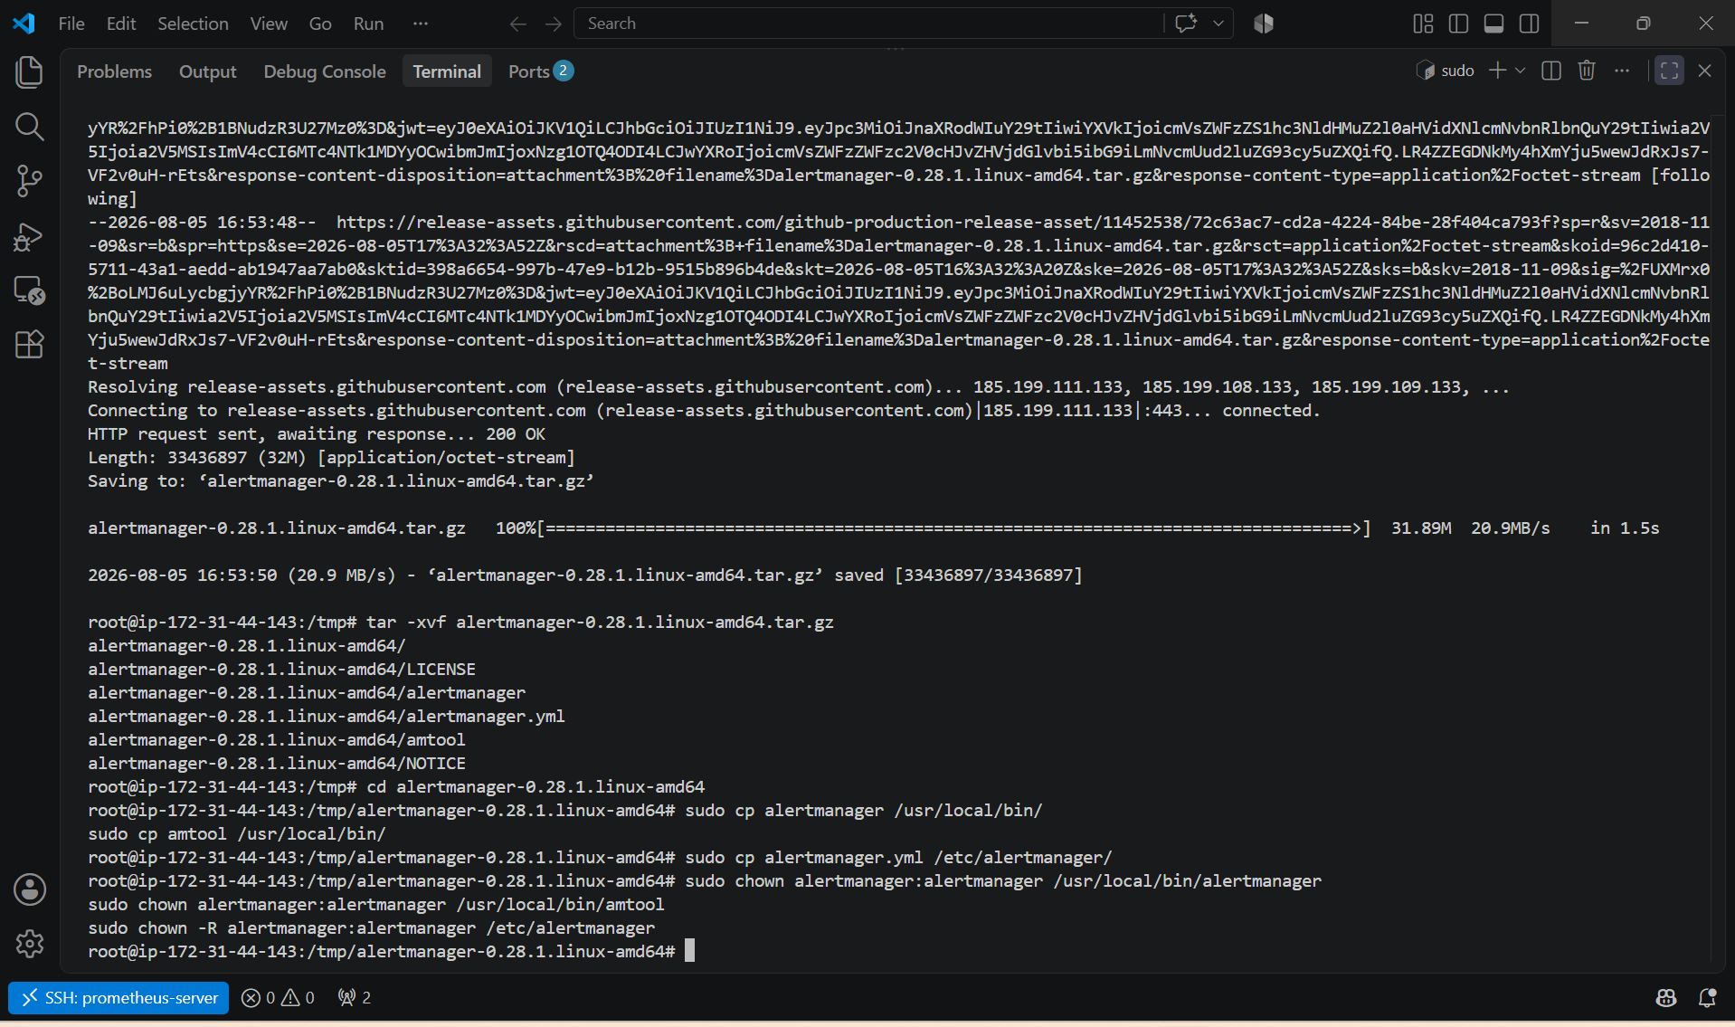
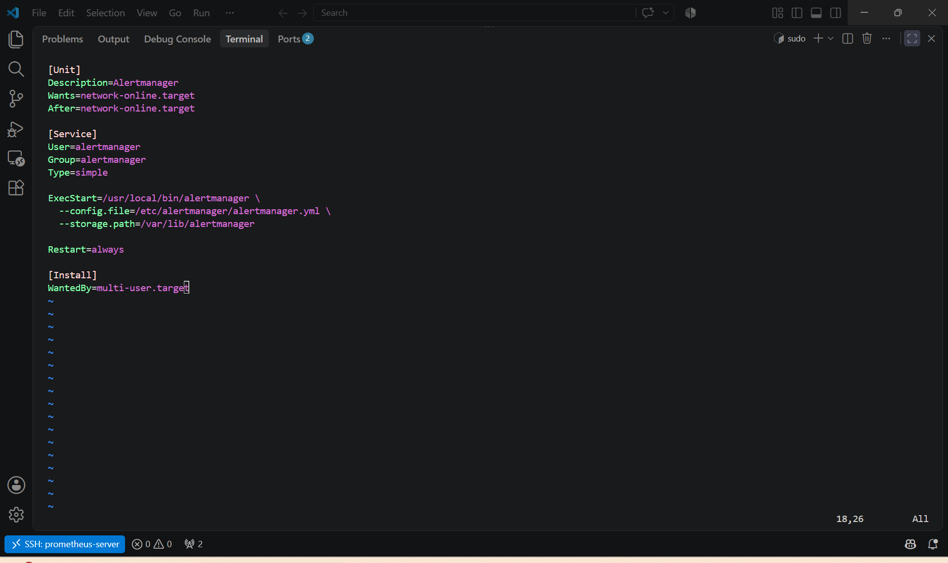

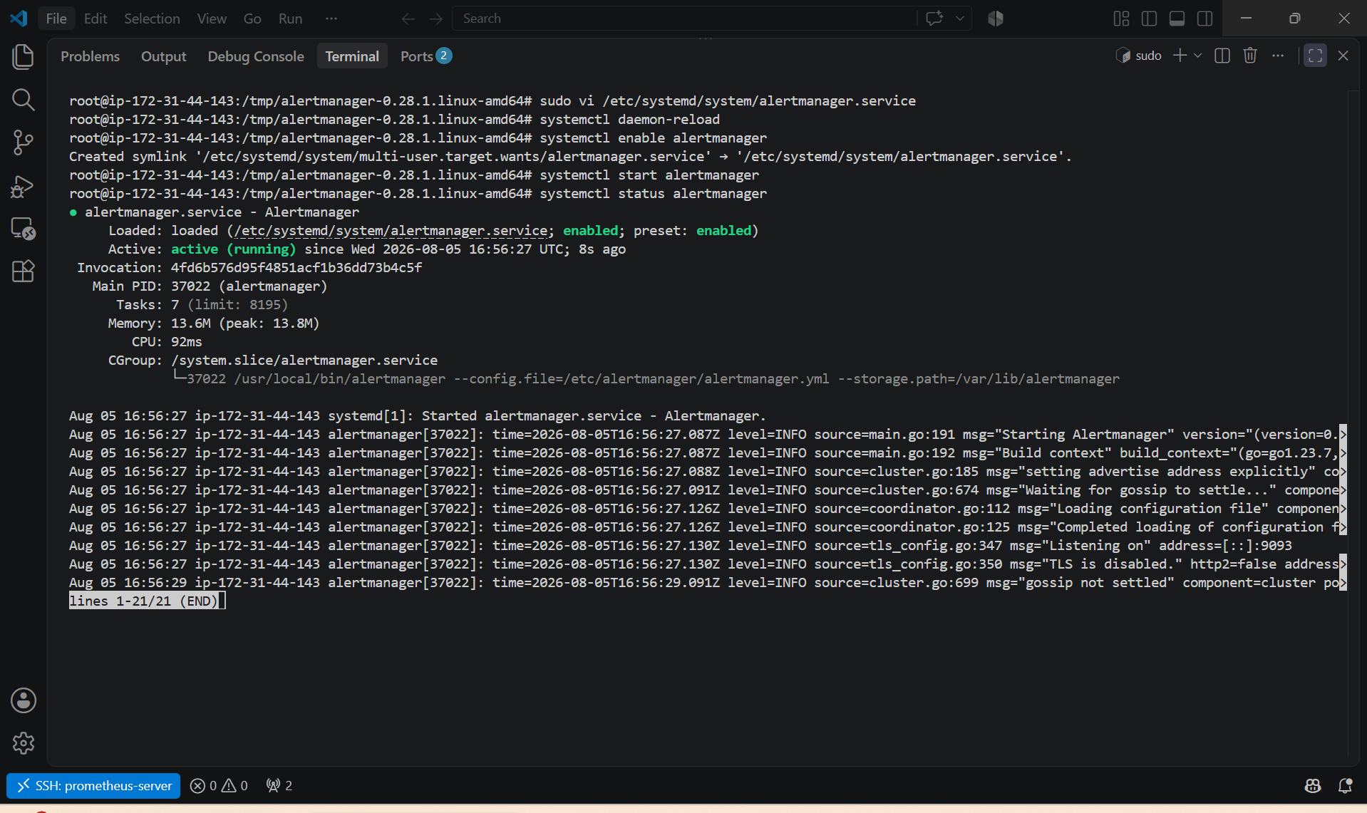

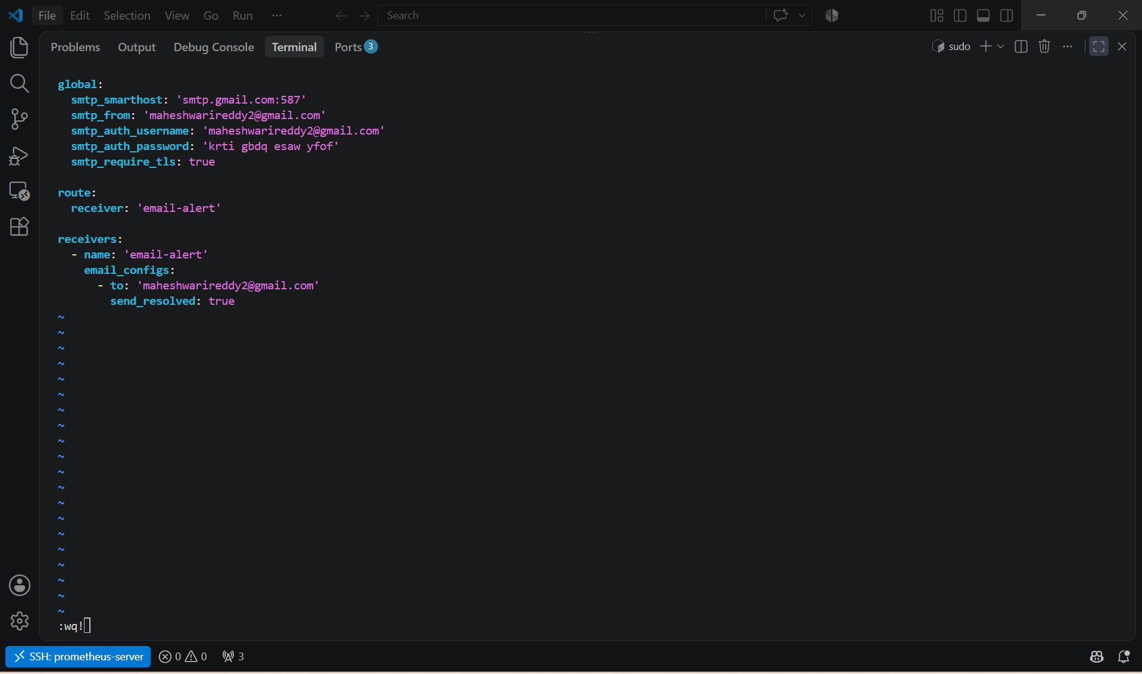

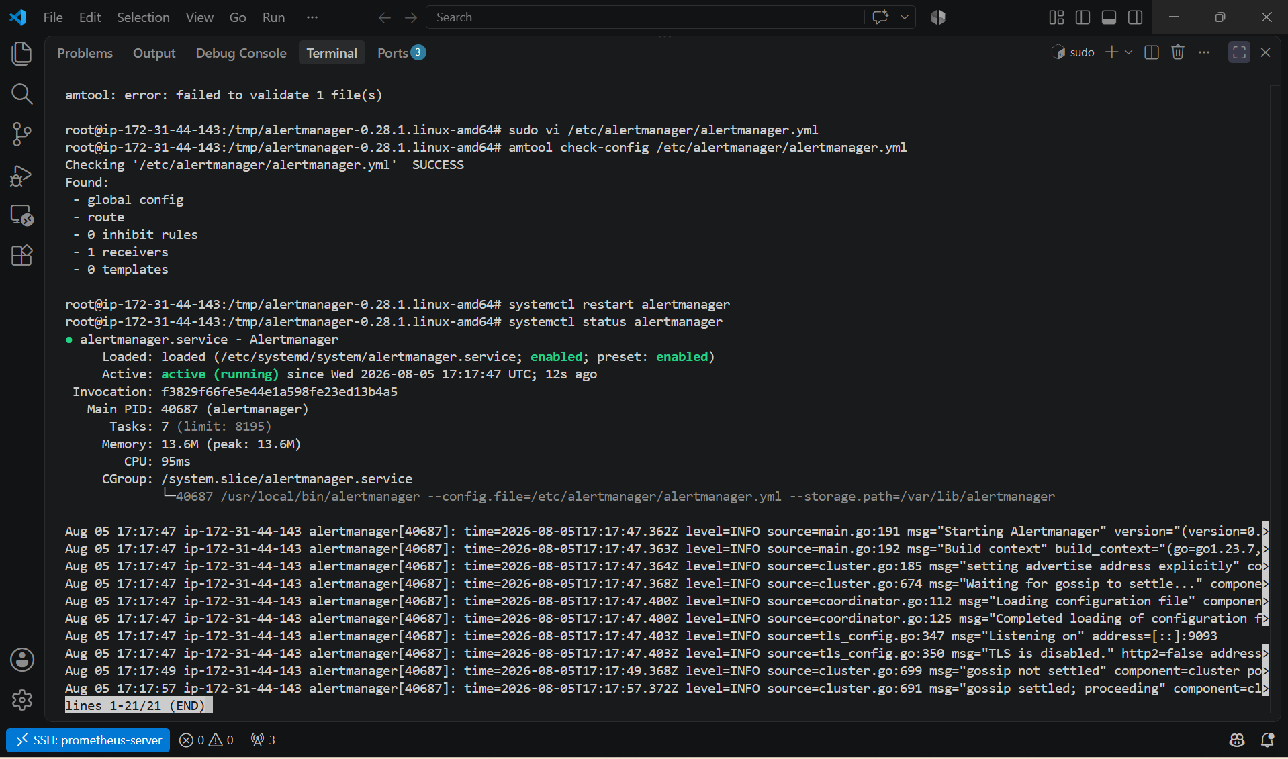

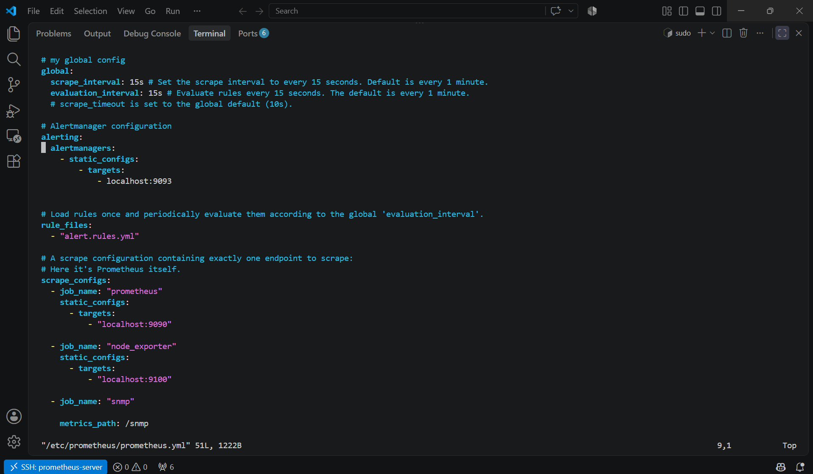

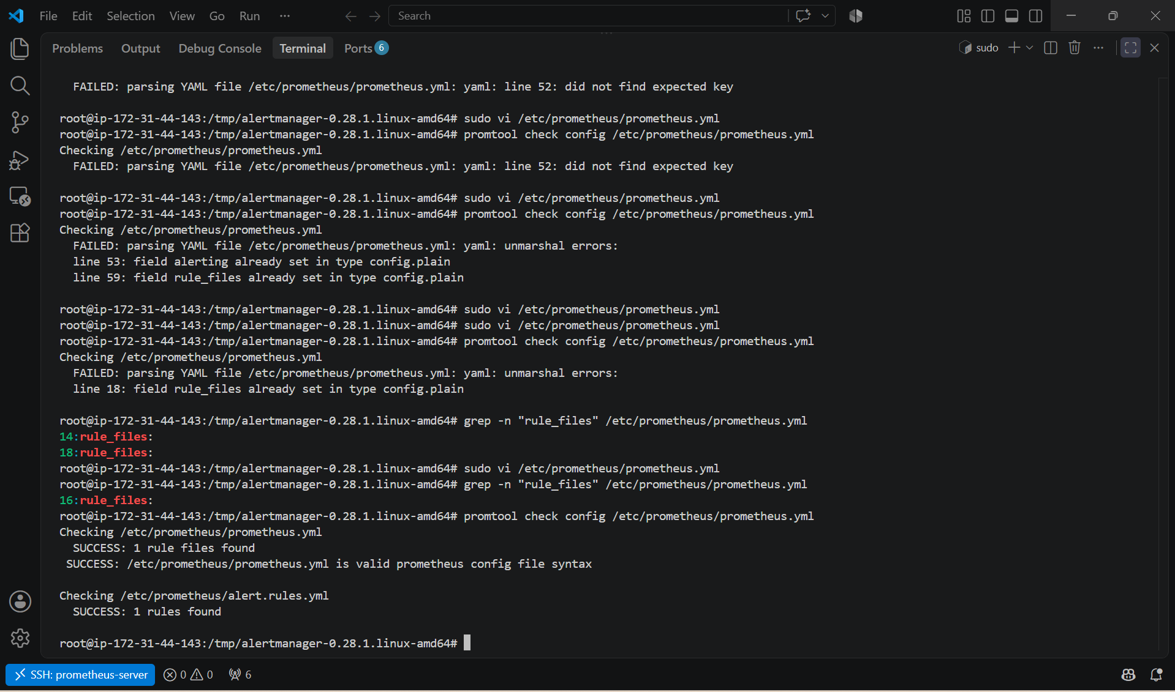

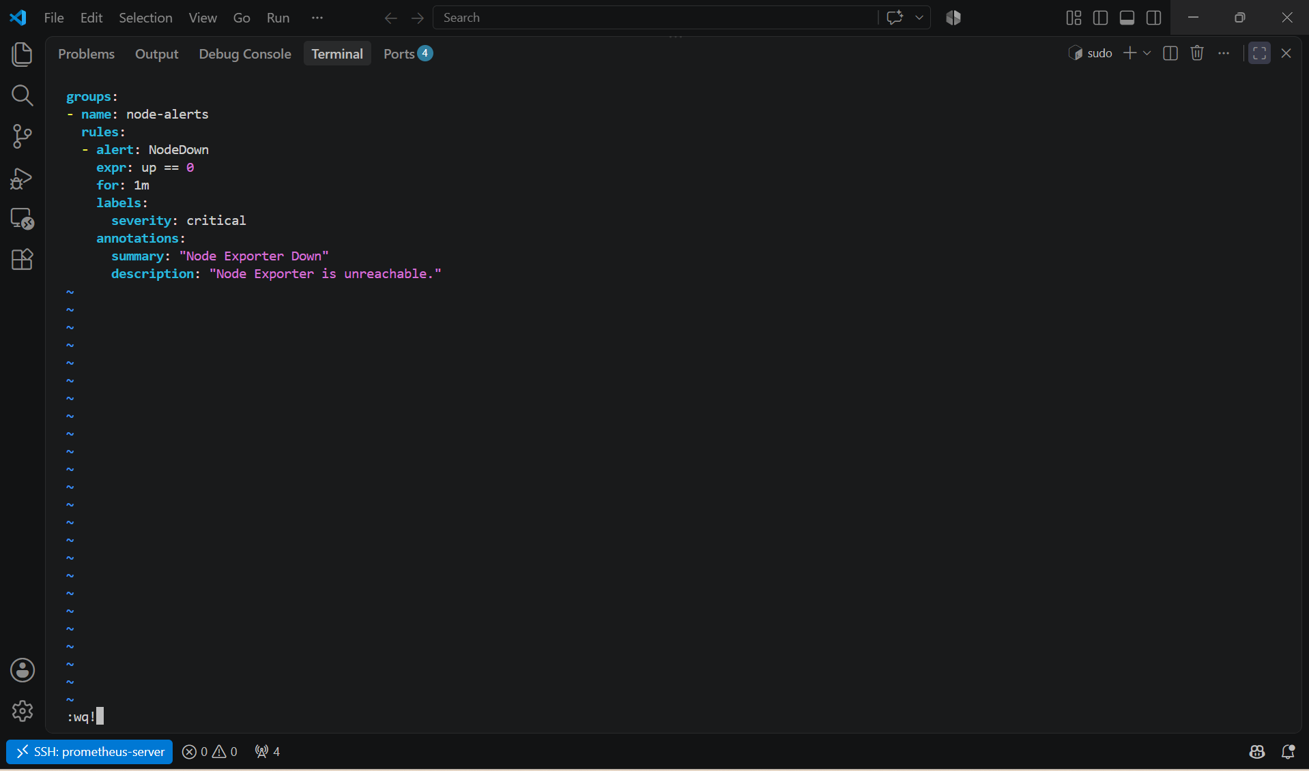

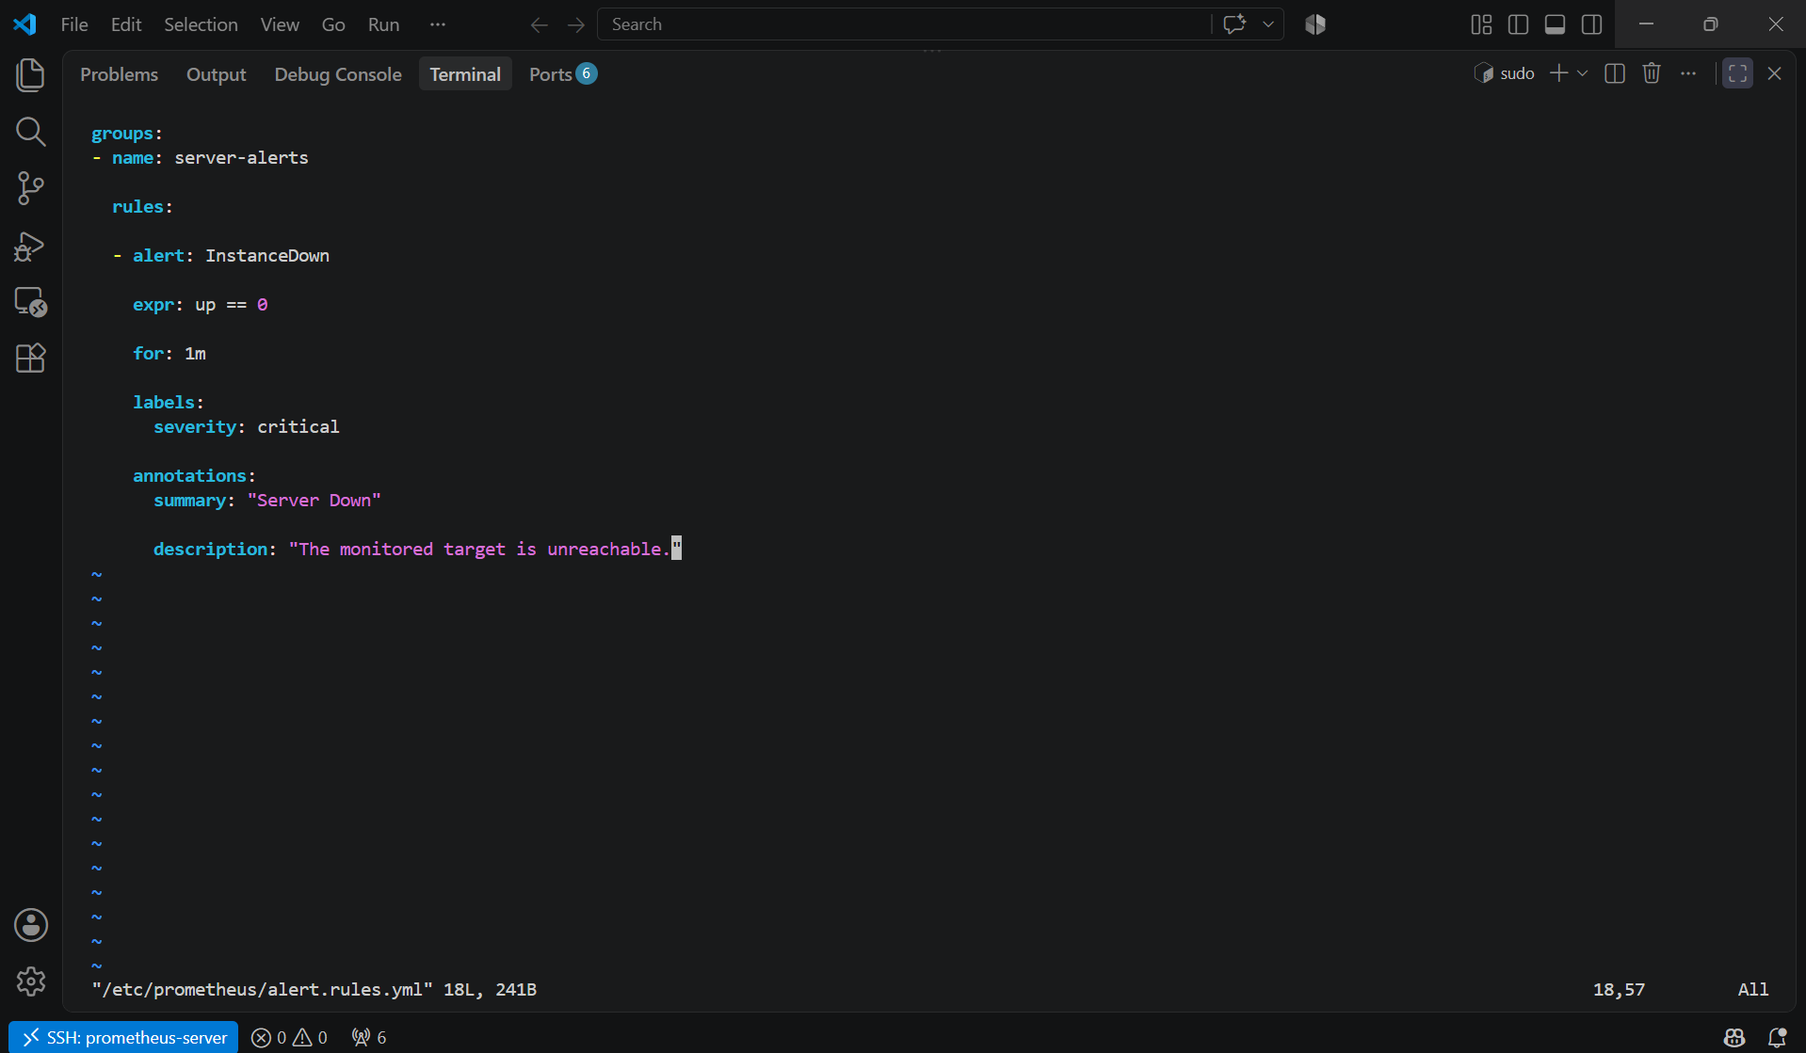

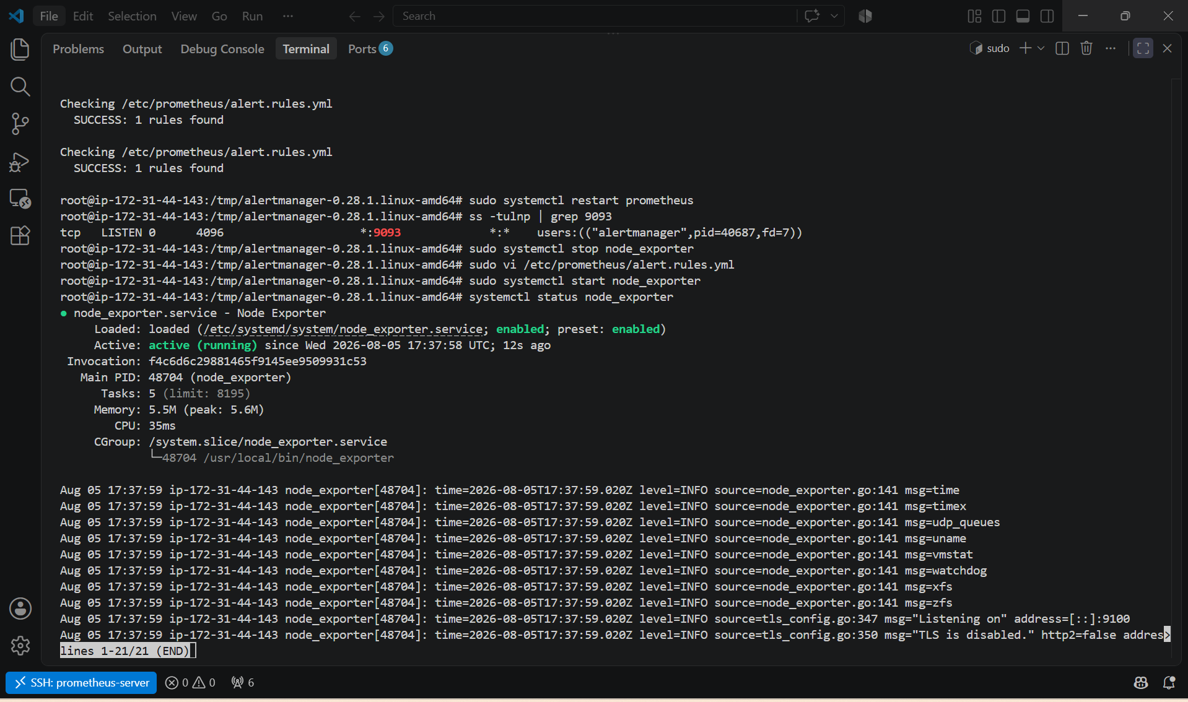

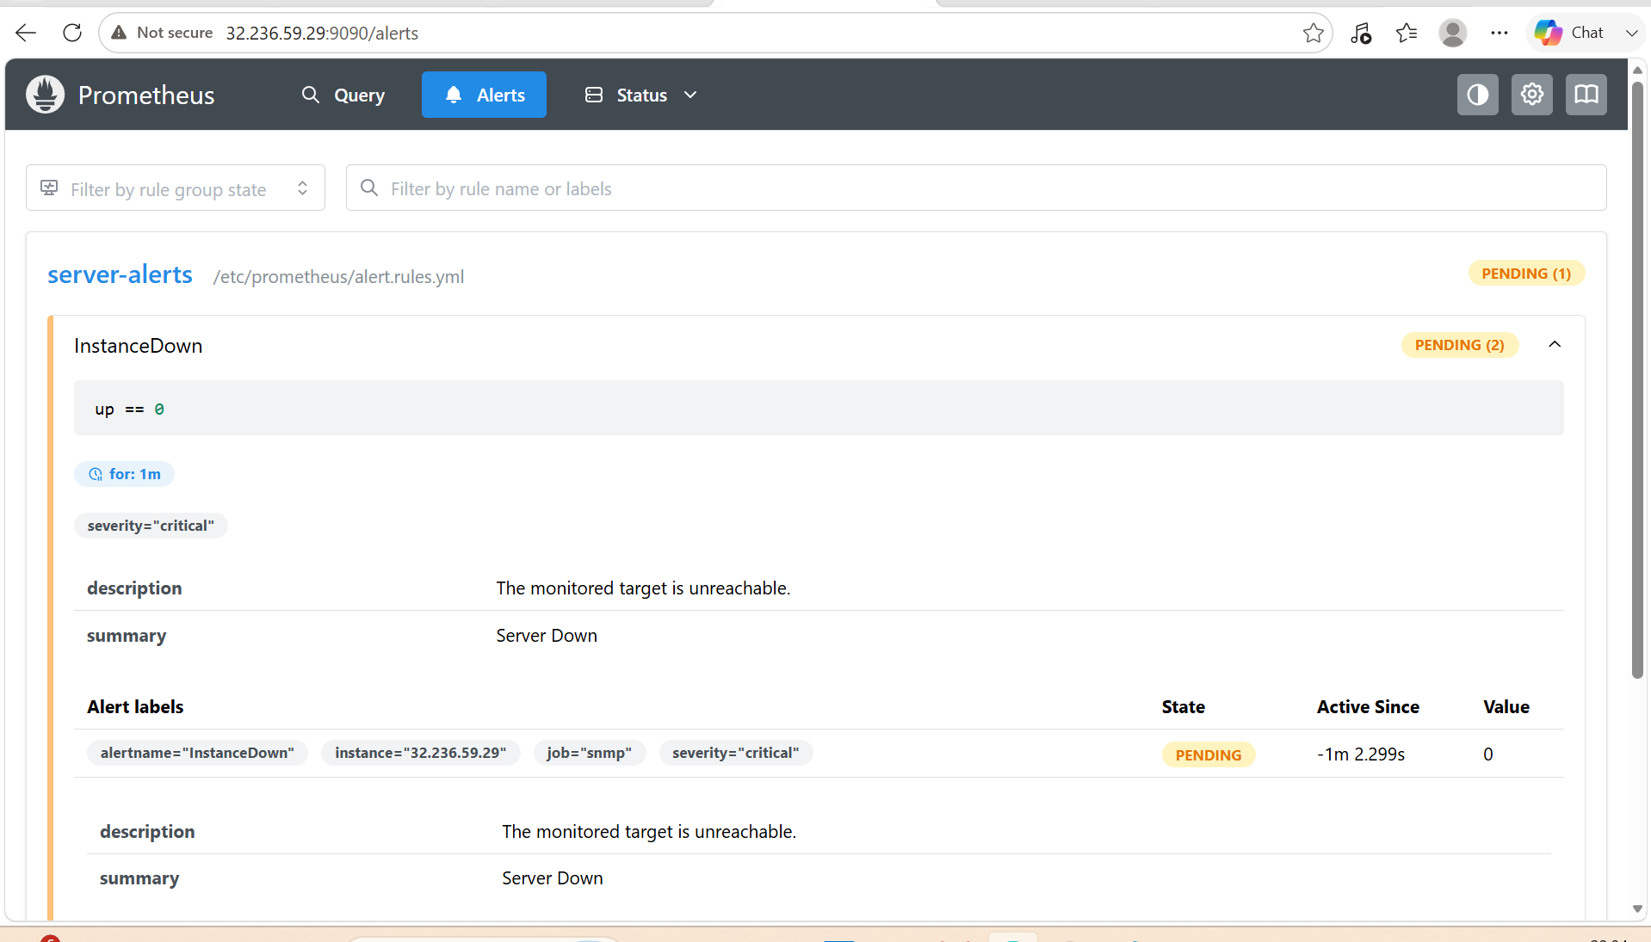

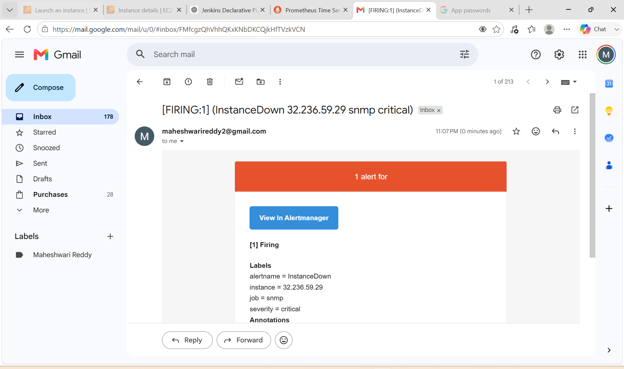

6. Install Grafana and add Prometheus as a data source.

PURPOSE:
- Install Grafana on Ubuntu.
- Start Grafana as a system service.
- Enable automatic startup after reboot.
- Access the Grafana web interface.
- Add Prometheus as a data source.
- Verify the connection between Grafana and Prometheus.

OBJECTIVE: To install Grafana, configure it as a system service, and connect it to Prometheus so you can create dashboards for monitoring your infrastructure

EXPECTED OUCOME:
- Grafana is installed and running as a systemd service.
- Grafana starts automatically after system reboot.
- The web interface is accessible on port 3000.
- Prometheus is successfully added as a data source.
- Grafana can query Prometheus metrics and is ready for creating dashboards.

STEP BY STEP IMPLEMENTATION:

Step 1: Update the Server
sudo apt update
sudo apt upgrade -y
Purpose: Updates package indexes and installs the latest updates.

Step 2: Install Required Packages
sudo apt install -y software-properties-common apt-transport-https wget
Purpose: Installs packages required to add external repositories.

Step 3: Import the Grafana GPG Key
wget -q -O - https://apt.grafana.com/gpg.key | \
sudo gpg --dearmor -o /usr/share/keyrings/grafana.gpg

Step 4: Add the Grafana Repository
echo "deb [signed-by=/usr/share/keyrings/grafana.gpg] https://apt.grafana.com stable main" | \
sudo tee /etc/apt/sources.list.d/grafana.list

Step 5: Install Grafana
sudo apt update

sudo apt install grafana -y
Verify the installation:
grafana-server -v

Step 6: Enable Grafana Service
sudo systemctl daemon-reload

sudo systemctl enable grafana-server

Step 7: Start Grafana
sudo systemctl start grafana-server
Check the status:
sudo systemctl status grafana-server
Expected:
Active: active (running)

Step 8: Verify the Listening Port
ss -tulnp | grep 3000
Expected:
LISTEN 0 4096 *:3000

Step 9: Allow Firewall (If UFW is Enabled)
sudo ufw allow 3000/tcp

sudo ufw reload
If you're using an AWS EC2 instance, ensure the Security Group allows inbound TCP 3000 from your IP address or 0.0.0.0/0 (for lab environments).

Step 10: Access Grafana
Open your browser:
http://<SERVER-IP>:3000
Example:
http://32.236.59.29:3000

Step 11: Login
Default credentials:
Username
admin
Password
admin
On the first login, Grafana will prompt you to change the password.

Step 12: Add Prometheus as a Data Source
- Click Connections → Data sources.
- Click Add data source.
- Select Prometheus.
Configure:
Name
Prometheus
URL
http://localhost:9090
If Grafana and Prometheus run on different servers, use the Prometheus server's IP address, for example:
http://32.236.59.29:9090
Leave the remaining settings as their defaults.
Click Save & Test.
Expected message:
Successfully queried the Prometheus API.

Step 13: Verify the Data Source
Go to:
Connections → Data sources → Prometheus
The status should show:
Data source is working

Step 14: Test Prometheus Metrics
- Click Explore.
- Select the Prometheus data source.
- Enter:
up
- Click Run Query.
Expected output:
up{job="prometheus"} 1

up{job="node_exporter"} 1
If SNMP Exporter is configured and working:
up{job="snmp"} 1

Step 15: Import a Dashboard (Optional)
- Click Dashboards → Import.
- Enter Dashboard ID:
1860
This imports the Node Exporter Full dashboard.
Select the Prometheus data source and click Import.

Useful Service Commands
Start Grafana:
sudo systemctl start grafana-server
Stop Grafana:
sudo systemctl stop grafana-server
Restart Grafana:
sudo systemctl restart grafana-server
Check status:
sudo systemctl status grafana-server
View logs:
sudo journalctl -u grafana-server -f

Verification Checklist
Run the following commands:
sudo systemctl status grafana-server

ss -tulnp | grep 3000

curl http://localhost:3000
You should also verify:
- Grafana is accessible at http://<SERVER-IP>:3000
- You can log in successfully.
- The Prometheus data source shows Successfully queried the Prometheus API.
- Running the up query returns metrics from Prometheus.

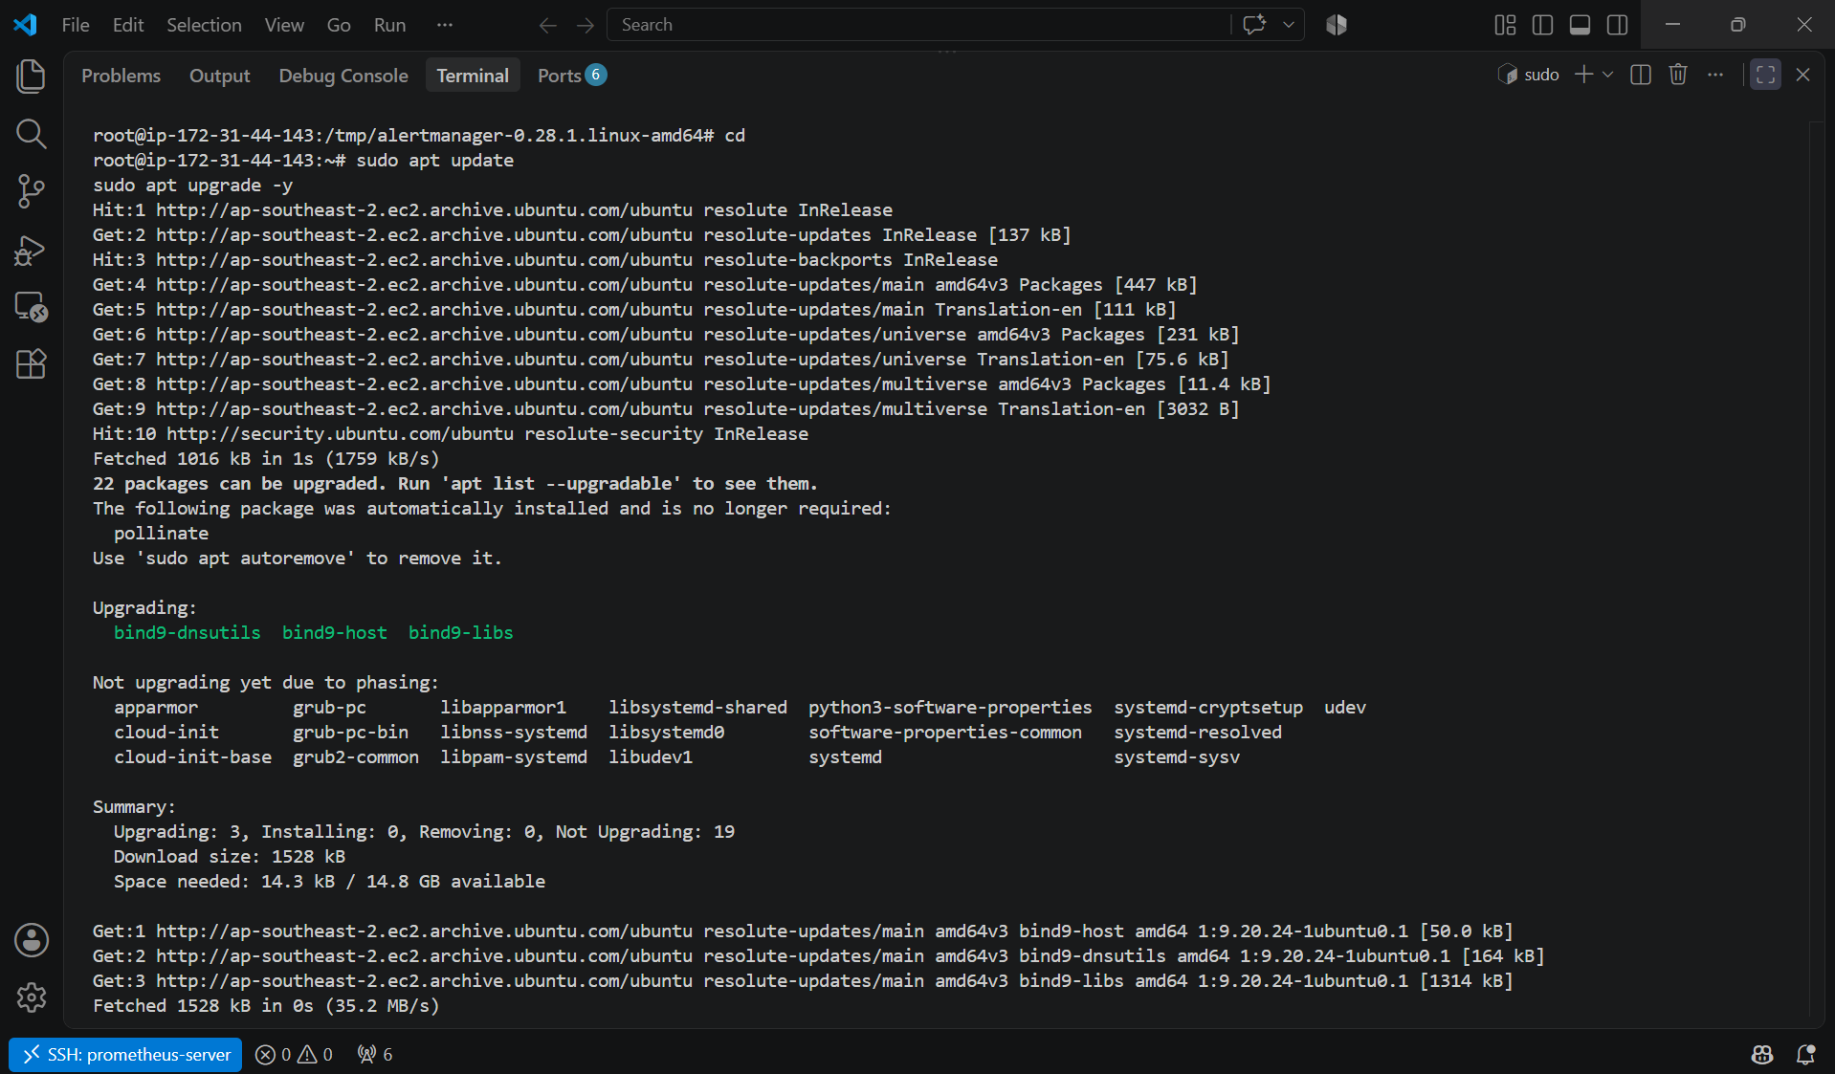

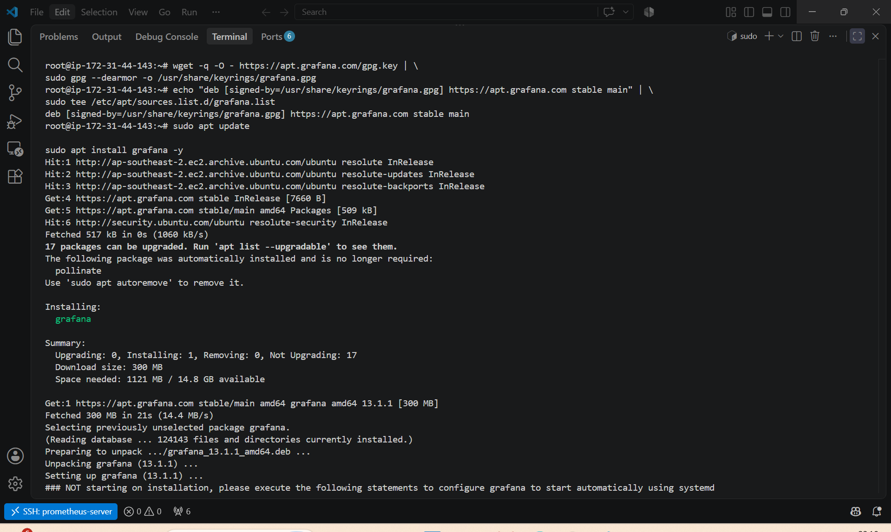

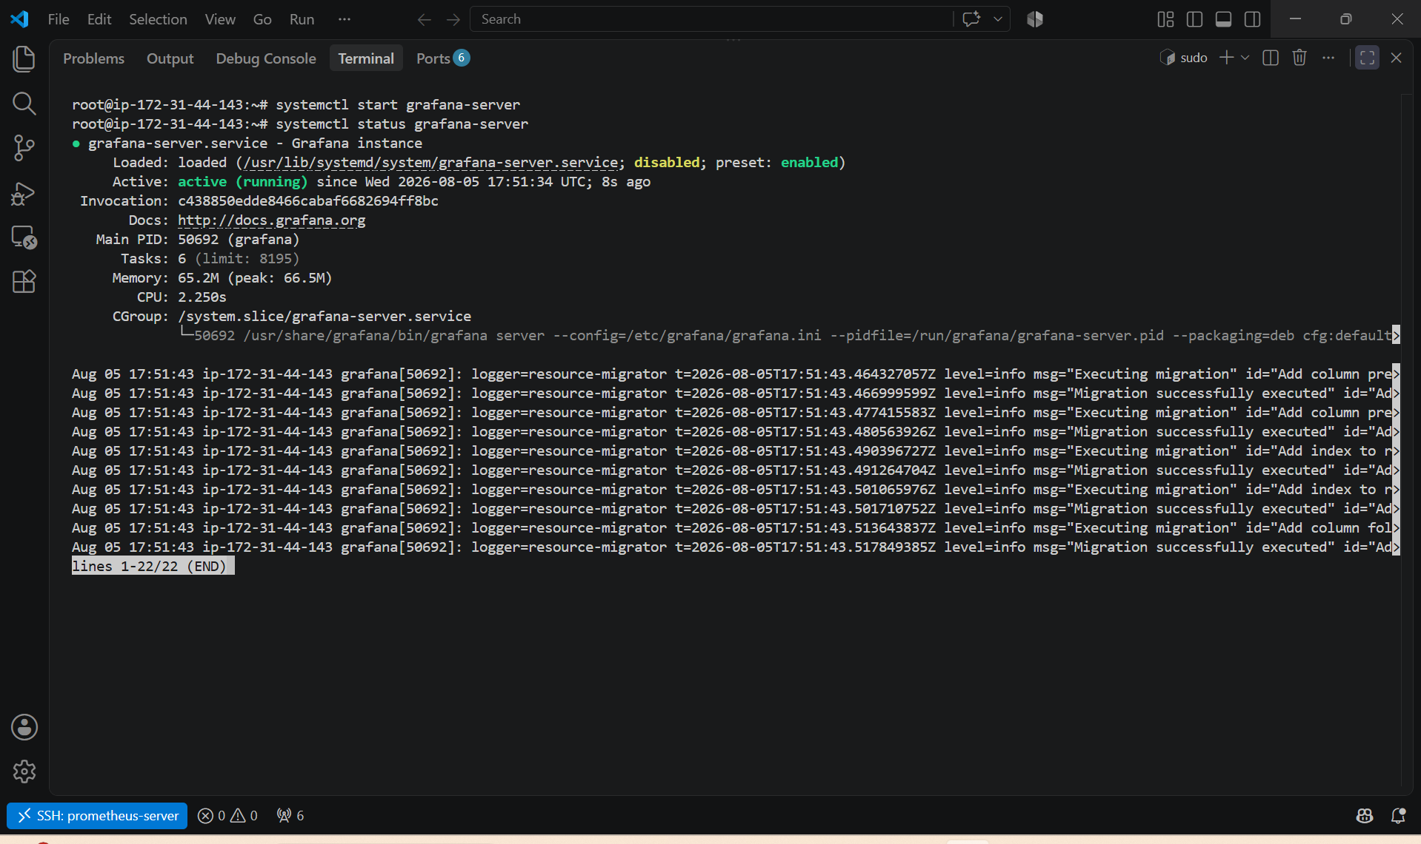

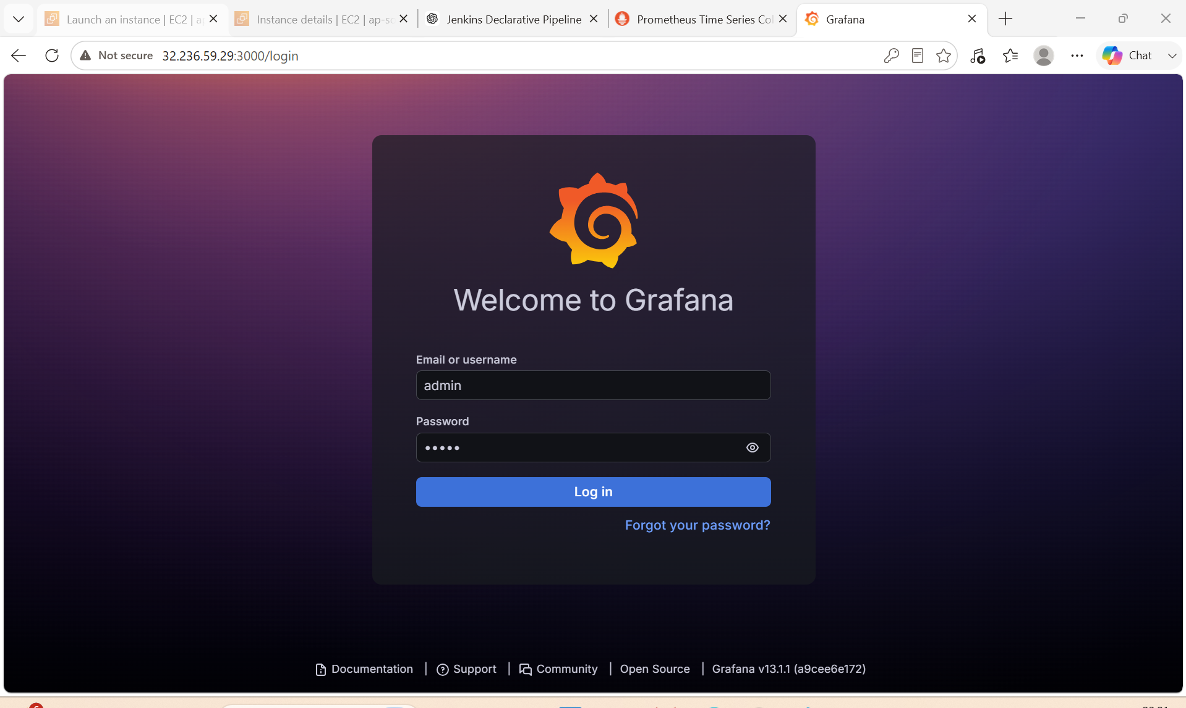

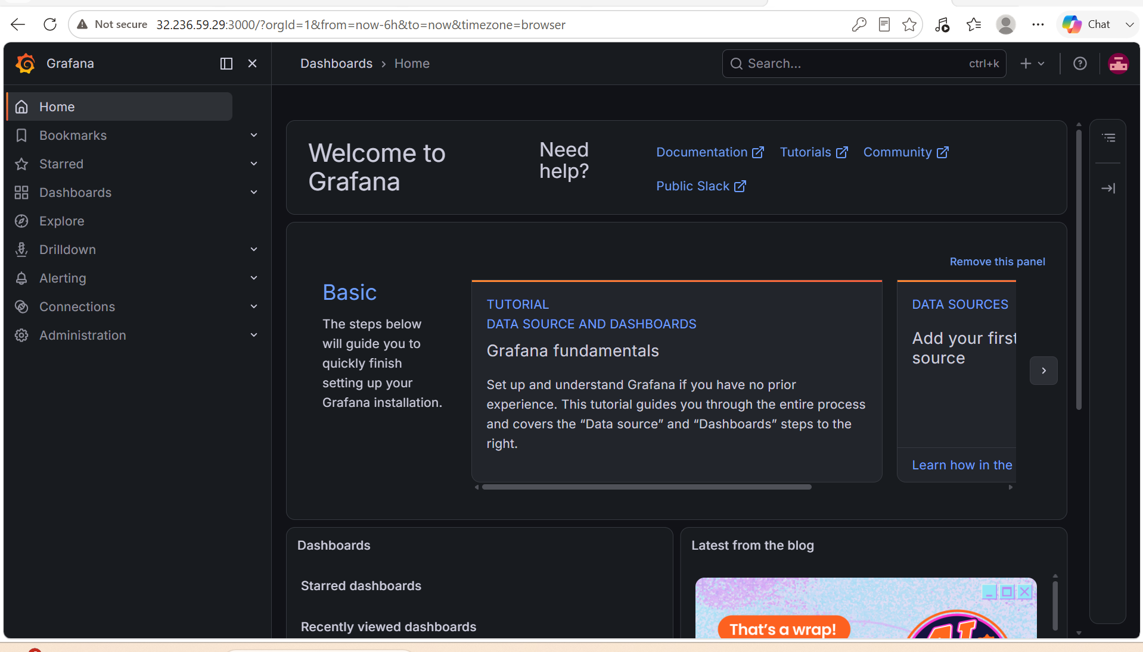

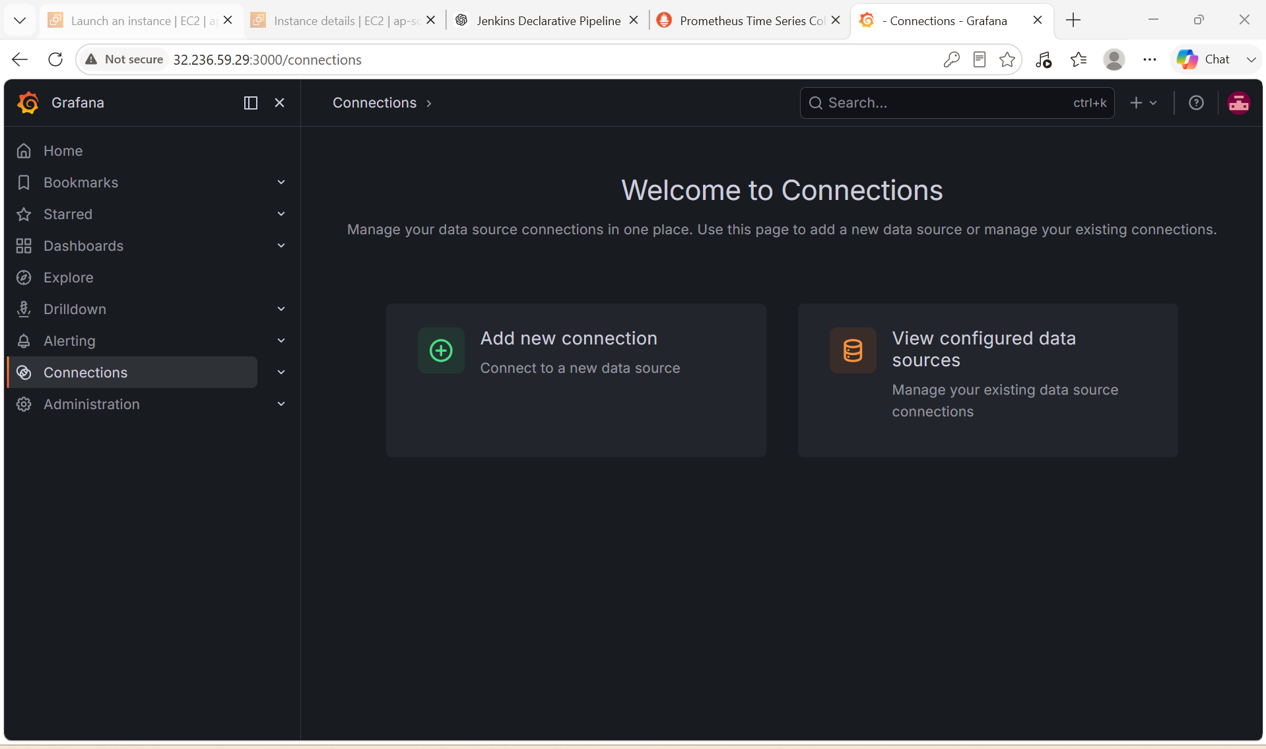

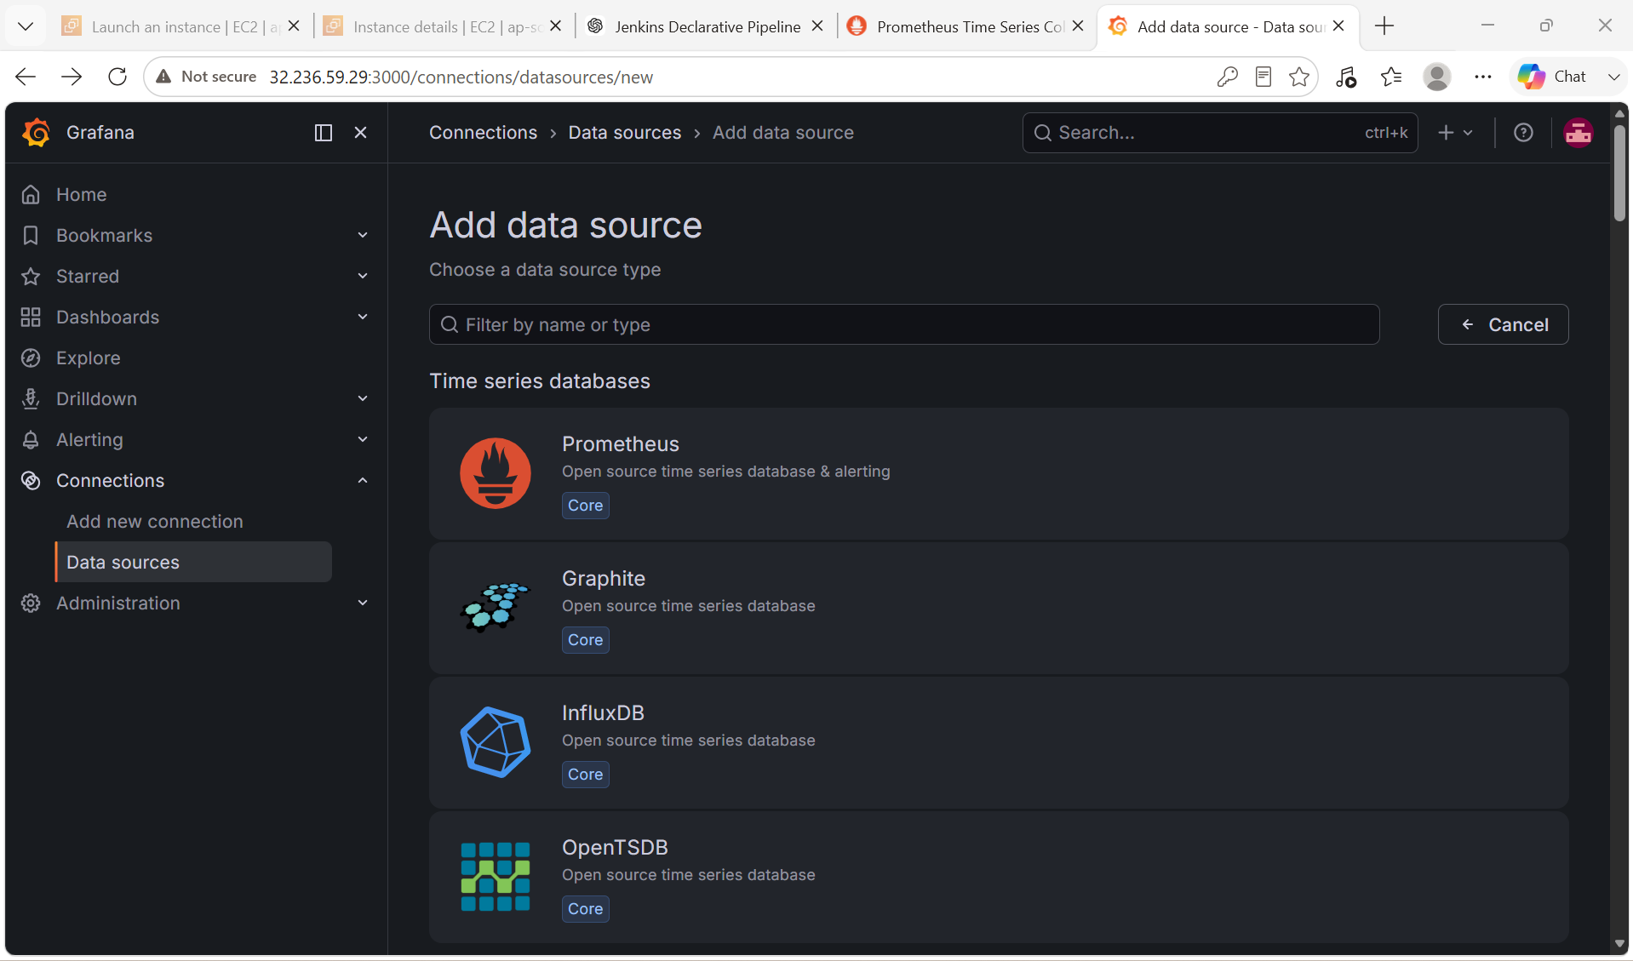

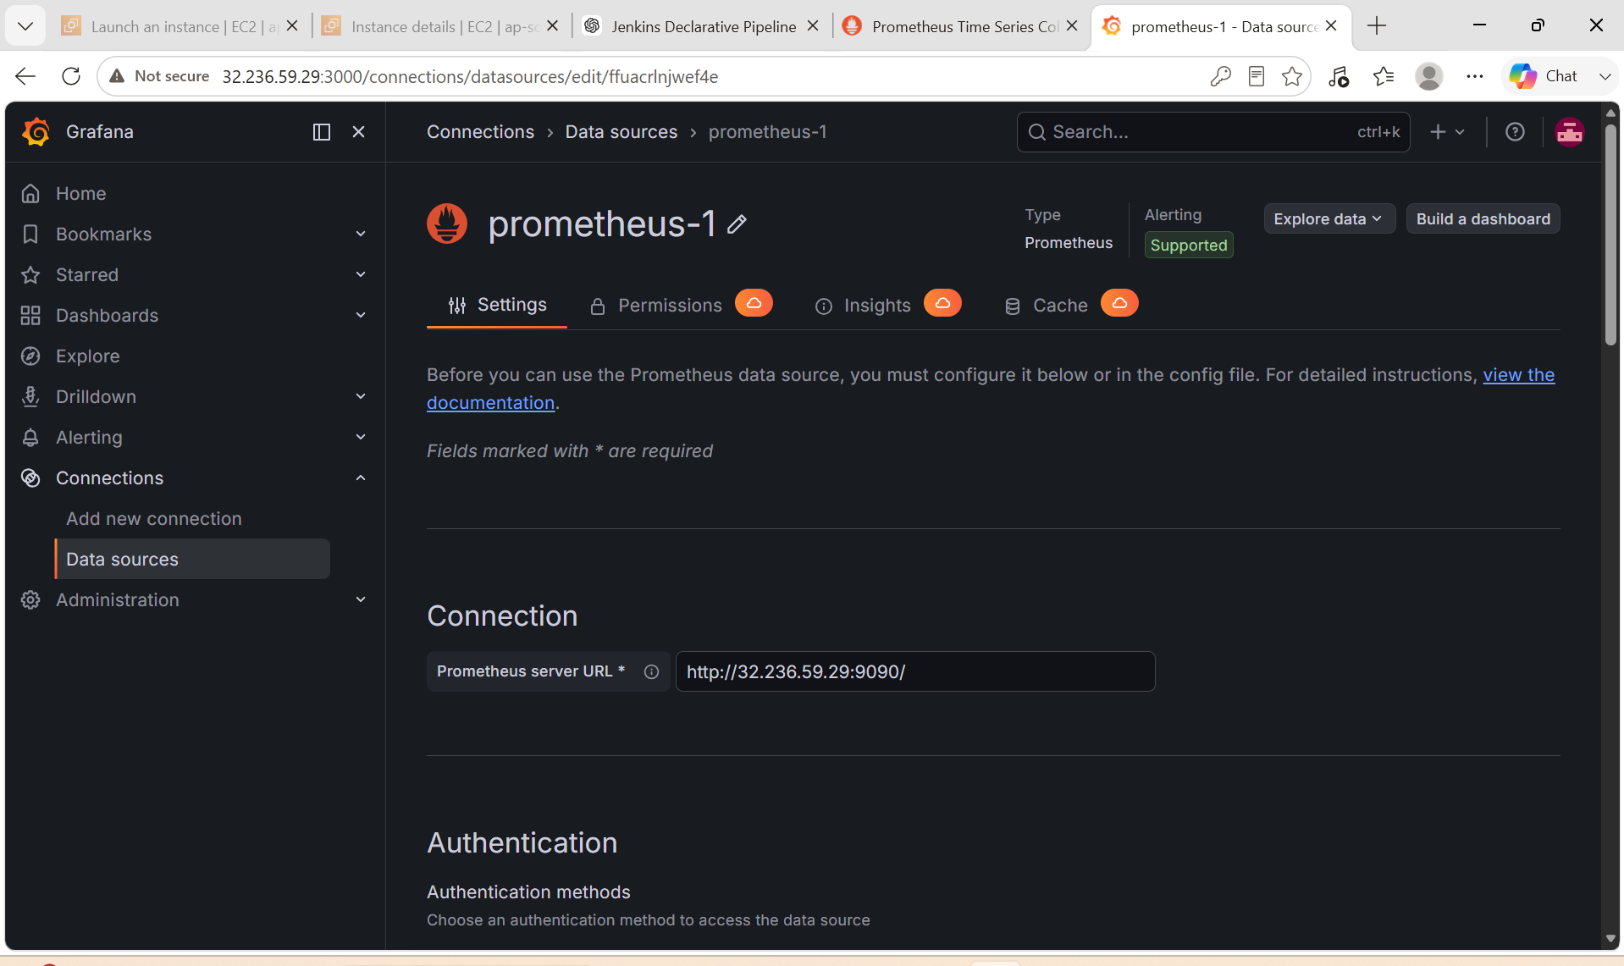

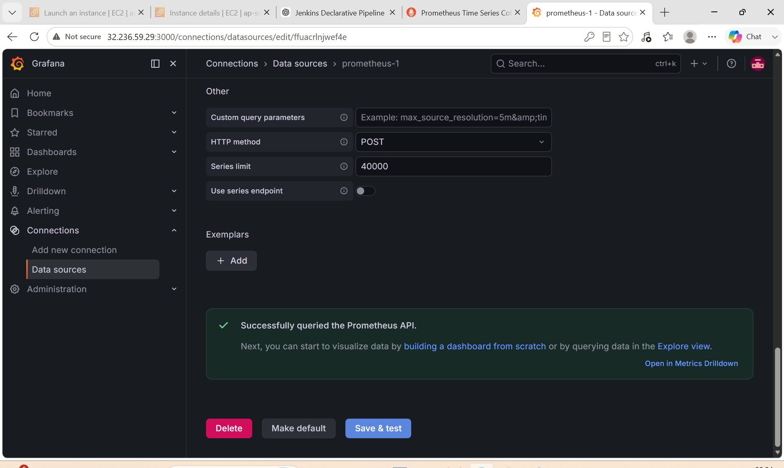

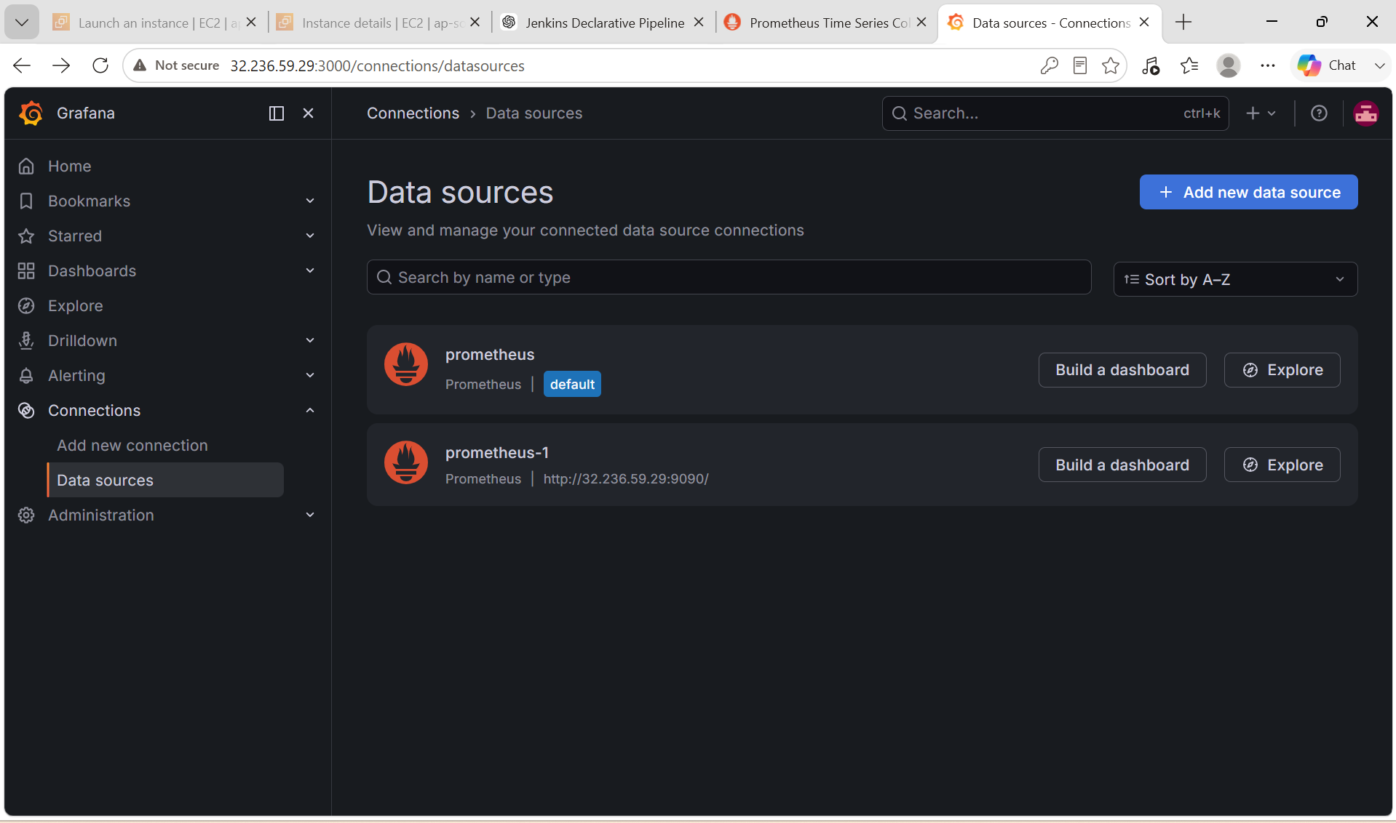
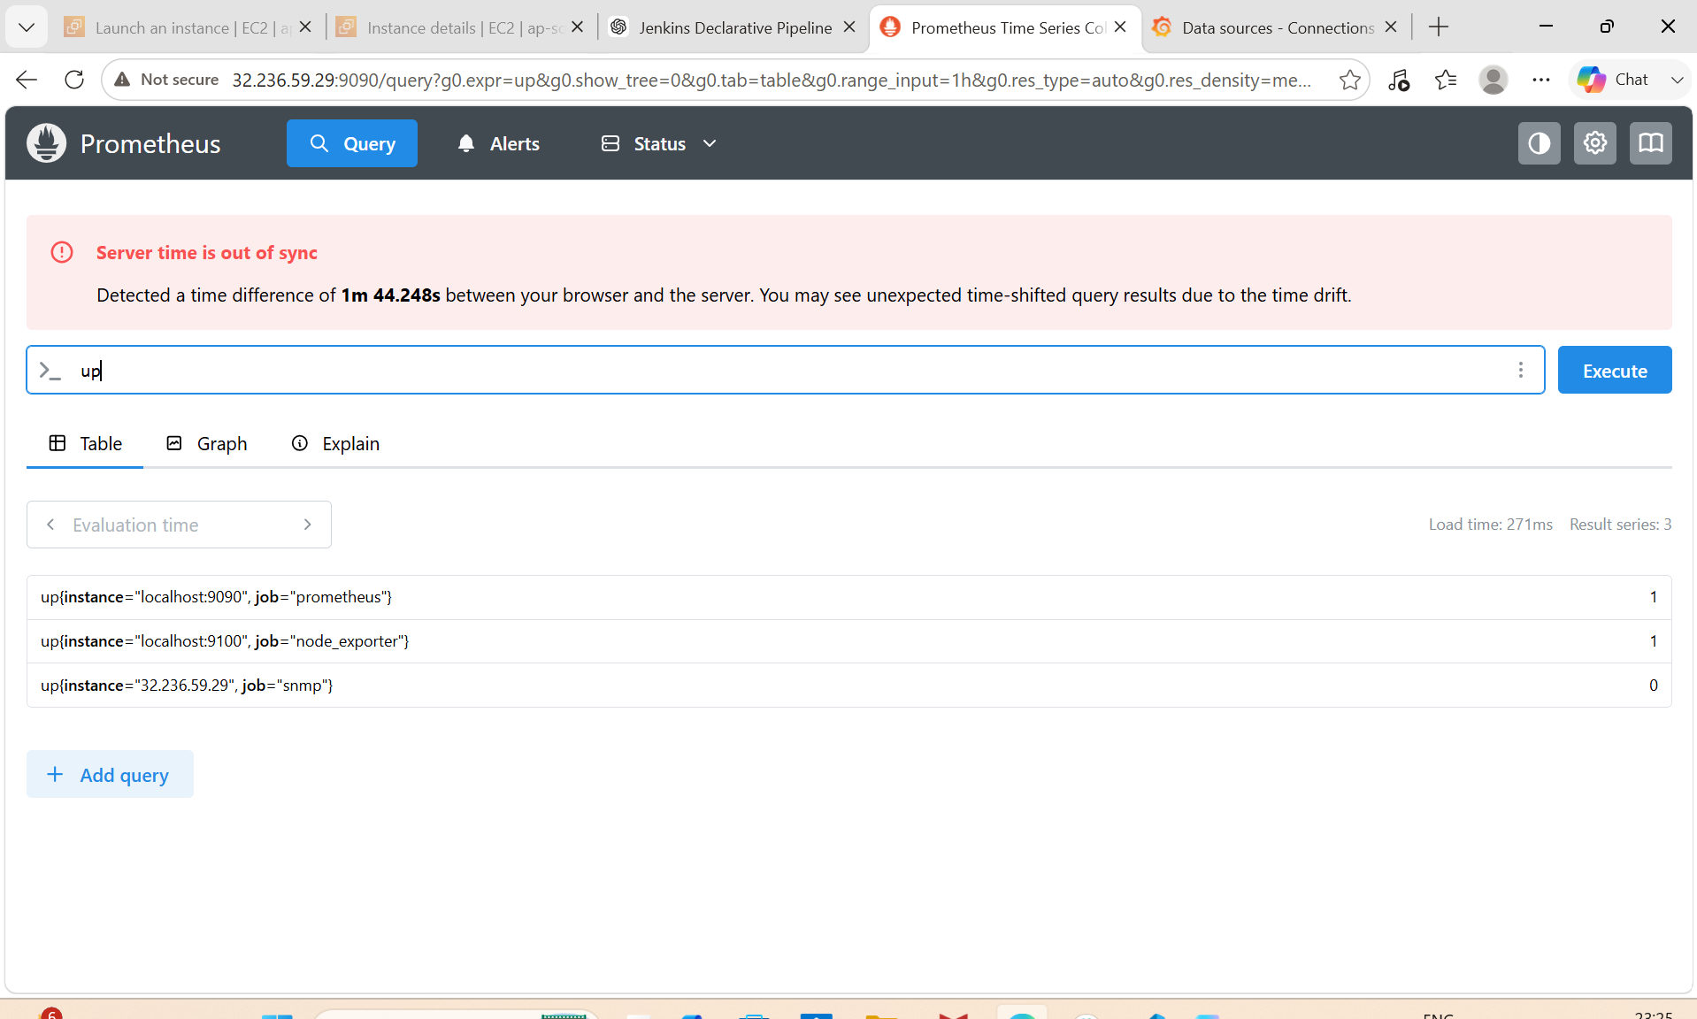

7. Configure Prometheus for service discovery of dynamic targets.

PURPOSE:
- Automatically discover new servers and services.
- Eliminate manual updates to prometheus.yml.
- Simplify monitoring in dynamic environments.
- Enable scalable monitoring for cloud and Kubernetes deployments.

OBJECTIVE: Configure Prometheus to automatically discover targets instead of manually adding them to prometheus.yml.

EXPECTED OUTCOME:
- Prometheus is configured for dynamic service discovery.
- Targets are read from files under /etc/prometheus/targets/.
- New targets are discovered automatically without restarting Prometheus.
- The Status → Targets page updates as targets are added or removed.
- The monitoring configuration becomes easier to maintain and more scalable.

What is Service Discovery?
Normally, Prometheus uses:
static_configs:
- targets:
- localhost:9100
This requires manually adding every server.
With Service Discovery, Prometheus automatically finds new targets from cloud providers, Kubernetes, Consul, Docker, or file-based configurations.

Service Discovery Methods

Method | Use Case
File Service Discovery | Static or lab environments
Kubernetes SD | Kubernetes clusters
EC2 SD | AWS EC2 instances
Consul SD | Consul service registry
Docker SD | Docker containers
DNS SD | DNS-based discovery

- For your current EC2 lab setup, File Service Discovery is the easiest and most appropriate method.

STEP BY STEP IMPLEMENTATION:

File Service Discovery (Recommended)
Step 1: Create a Target File
sudo mkdir -p /etc/prometheus/targets

sudo vi /etc/prometheus/targets/node_targets.yml
Add:
- targets:
- localhost:9100
labels:
job: node_exporter

- targets:
- localhost:9116
labels:
job: snmp_exporter
Purpose: Defines the targets Prometheus should monitor.

Step 2: Update prometheus.yml
Edit:
sudo vi /etc/prometheus/prometheus.yml
Replace the static job with:
scrape_configs:

- job_name: "dynamic-node"

file_sd_configs:
- files:
- /etc/prometheus/targets/*.yml

refresh_interval: 30s
Purpose: Prometheus checks the target files every 30 seconds and automatically loads changes.

Step 3: Validate Configuration
promtool check config /etc/prometheus/prometheus.yml
Expected:
SUCCESS

Step 4: Restart Prometheus
sudo systemctl restart prometheus

Step 5: Verify Targets
Open:
http://<SERVER-IP>:9090
Navigate to:
Status → Targets
You should see:
- localhost:9100
- localhost:9116

Add a New Target Dynamically
Edit the target file:
sudo vi /etc/prometheus/targets/node_targets.yml
Append:
- targets:
- 192.168.1.50:9100

labels:
job: remote-node
Save the file.
No restart is required.
After approximately 30 seconds, the new target appears automatically in Prometheus.

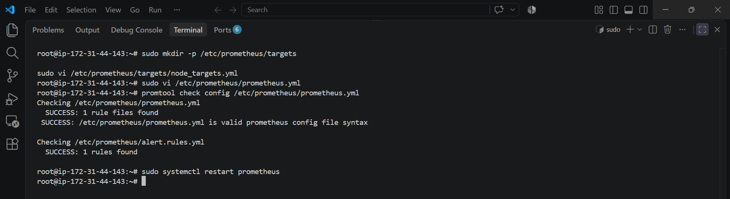

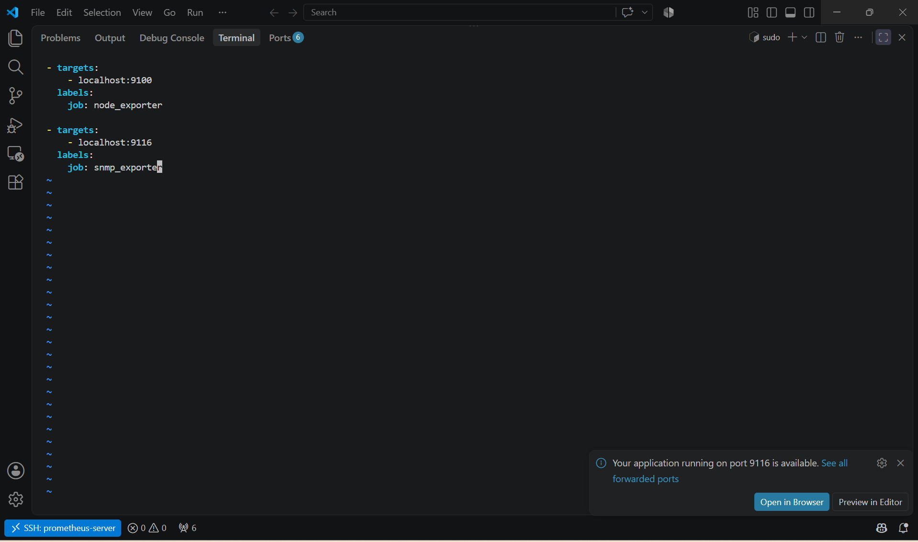

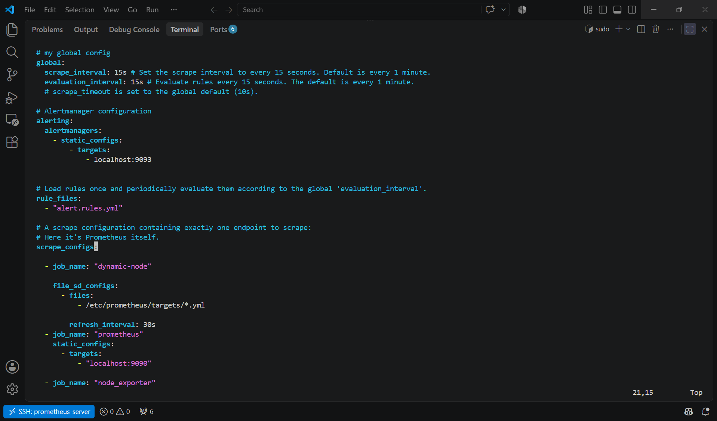

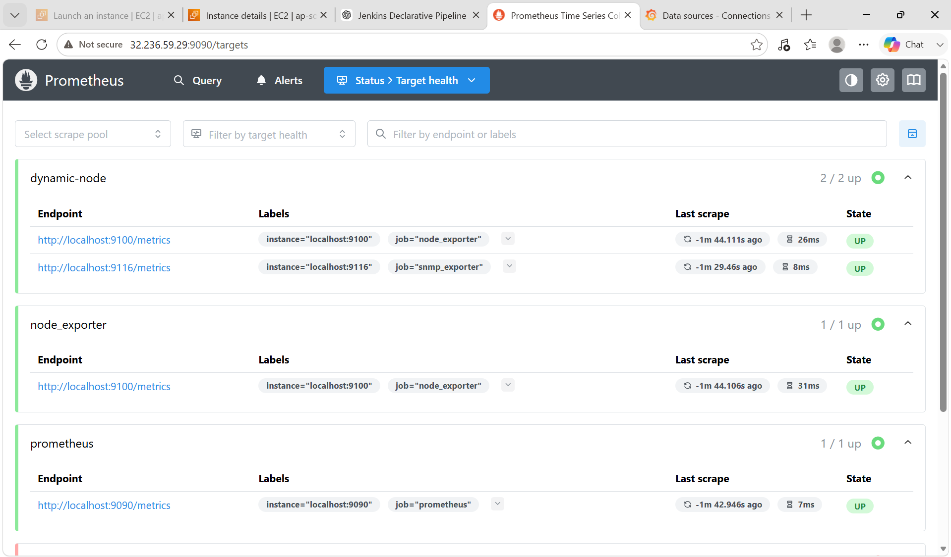

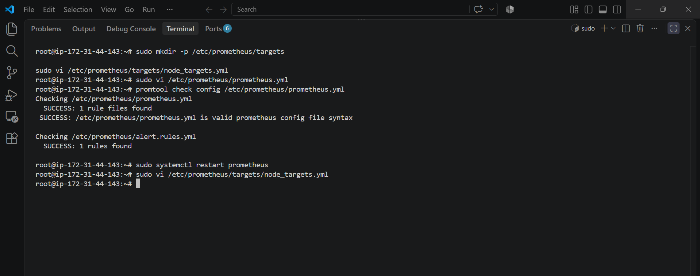

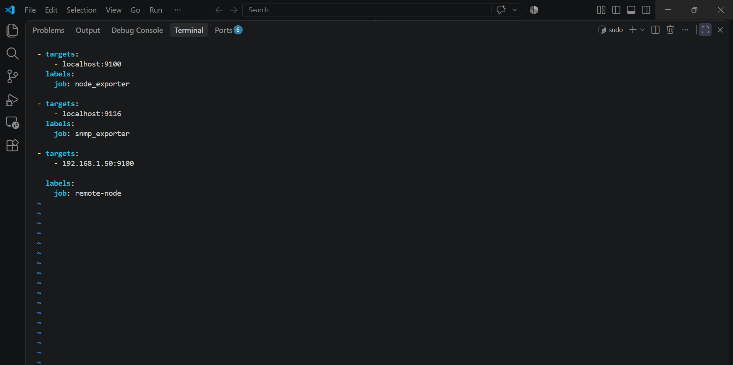

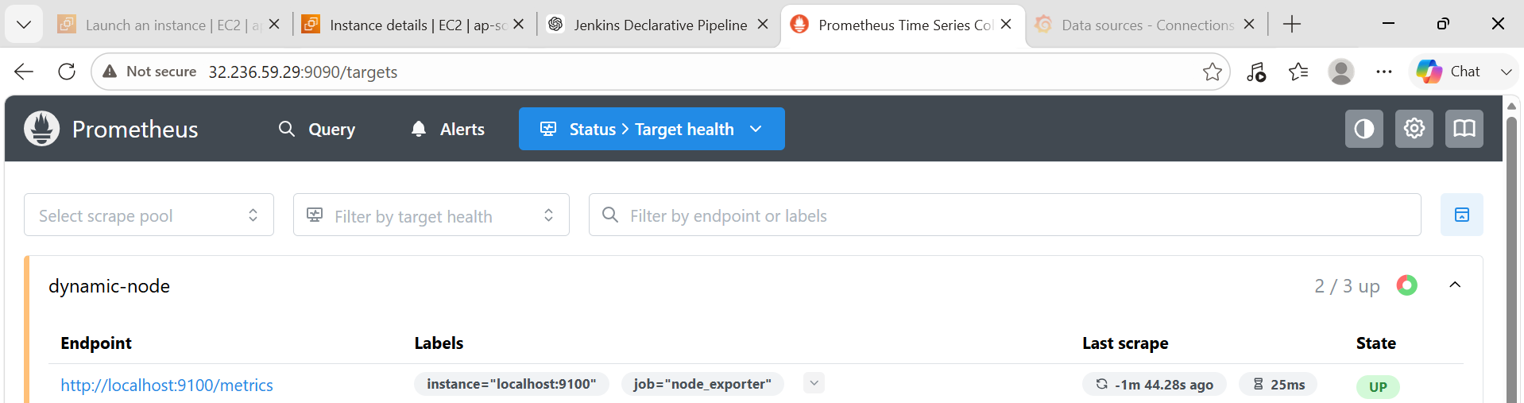

8. Create alerting rules for monitoring disk space.

PURPOSE:
- Monitor available disk space.
- Detect low disk space before it causes service failures.
- Send alerts to Alertmanager when disk usage exceeds the threshold.
- Improve server availability through proactive monitoring.

OBJECTIVE: Create Prometheus alerting rules that monitor disk usage using Node Exporter metrics and trigger alerts when disk usage exceeds a defined threshold.

EXPECTED OUTCOME:
- Prometheus continuously monitors disk usage through Node Exporter.
- An alert is triggered if root filesystem usage stays above 80% for 2 minutes.
- The alert appears in Prometheus and is forwarded to Alertmanager.
- Email notifications (if configured) are sent when the alert fires and when it resolves.

STEP BY STEP IMPLEMENTATION:

Step 1: Create an Alert Rule File
Create the alert rule file:
sudo vi /etc/prometheus/alert.rules.yml

Step 2: Add Disk Space Alert Rule
Paste the following configuration:
groups:
- name: disk-alerts

rules:

- alert: HighDiskUsage

expr: (
(node_filesystem_size_bytes{fstype!~"tmpfs|overlay",mountpoint="/"} -
node_filesystem_avail_bytes{fstype!~"tmpfs|overlay",mountpoint="/"})
/
node_filesystem_size_bytes{fstype!~"tmpfs|overlay",mountpoint="/"}
) * 100 > 80

for: 2m

labels:
severity: warning

annotations:
summary: "Disk Usage Above 80%"

description: "Disk usage on {{ $labels.instance }} is above 80%."
Purpose
- Triggers an alert if the root (/) filesystem usage exceeds 80% for 2 minutes.
- Ignores temporary (tmpfs) and overlay filesystems.

Step 3: Verify Prometheus Configuration
Ensure prometheus.yml contains:
rule_files:
- "alert.rules.yml"

Step 4: Validate the Alert Rules
Run:
promtool check rules /etc/prometheus/alert.rules.yml
Expected:
SUCCESS: 1 rules found

Step 5: Validate Prometheus Configuration
promtool check config /etc/prometheus/prometheus.yml
Expected:
SUCCESS: /etc/prometheus/prometheus.yml is valid

Step 6: Restart Prometheus
sudo systemctl restart prometheus
Verify:
sudo systemctl status prometheus
Expected:
Active: active (running)

Step 7: Verify the Alert
Open Prometheus:
http://<SERVER-IP>:9090
Navigate to:
Alerts
You should see:
HighDiskUsage
Initially, it will be Inactive until the threshold is exceeded.

Step 8: Test the Alert
To test, you can temporarily consume disk space (be careful not to fill the disk completely):
fallocate -l 5G /tmp/testfile
Check disk usage:
df -h
If usage exceeds 80%, after about 2 minutes, the alert will become Firing.

Step 9: Remove the Test File
rm -f /tmp/testfile
Restart Prometheus (optional):
sudo systemctl restart prometheus
The alert will automatically resolve once disk usage drops below the threshold.

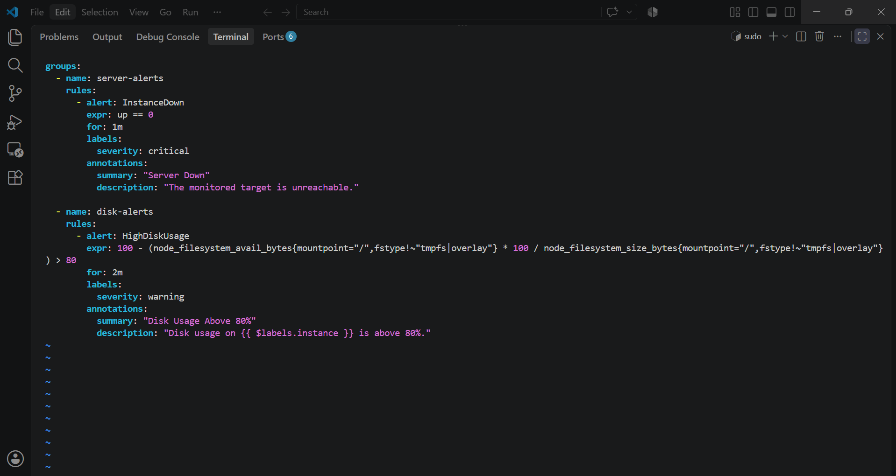
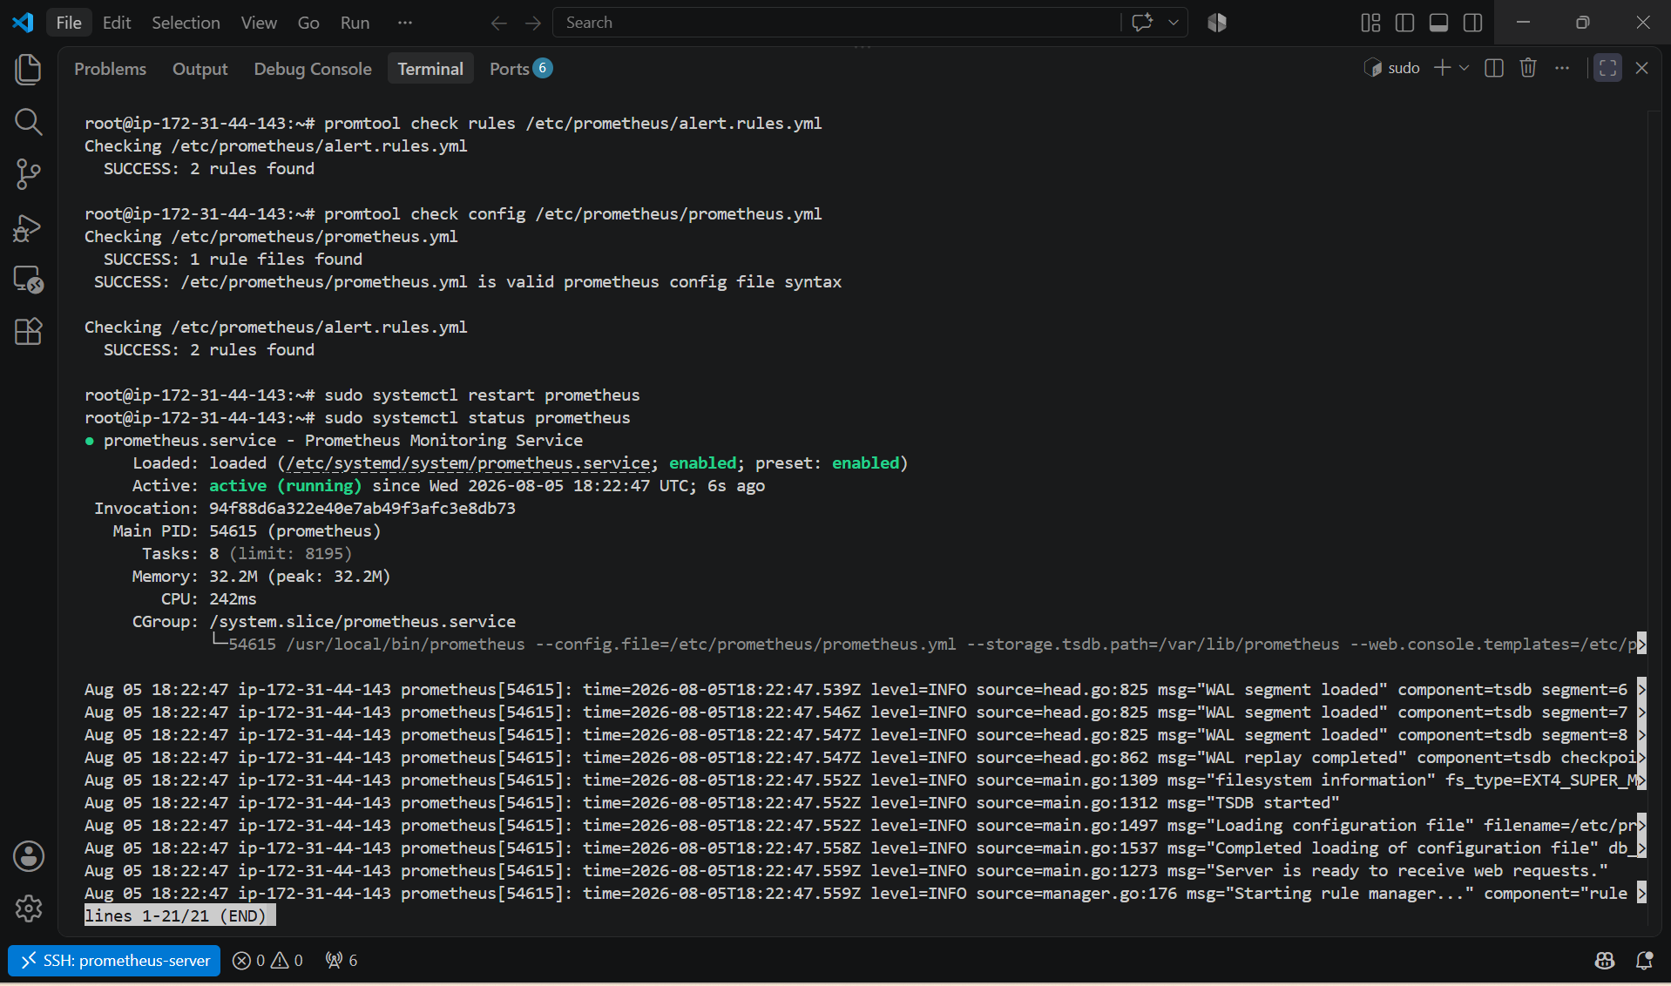

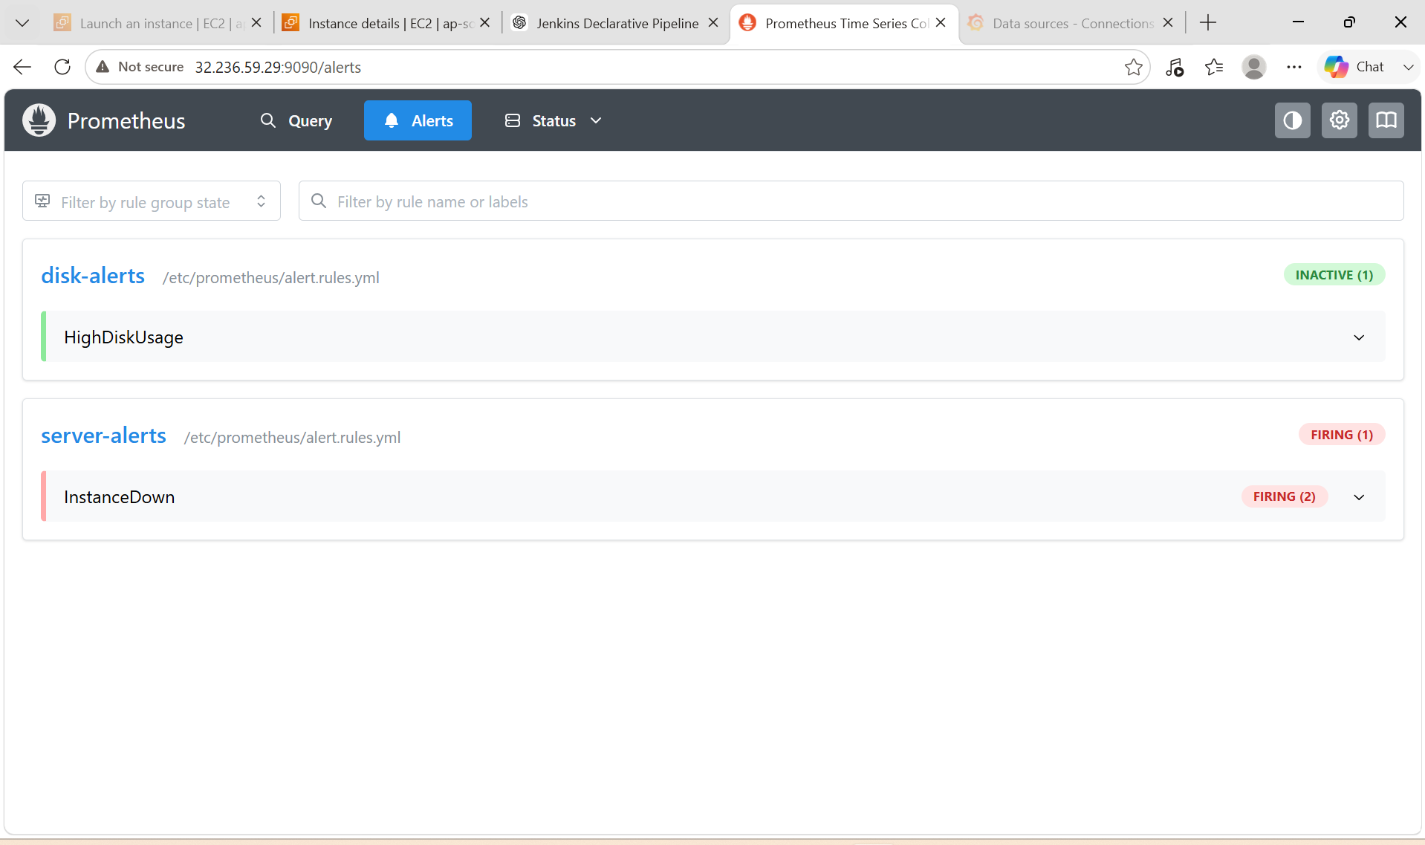

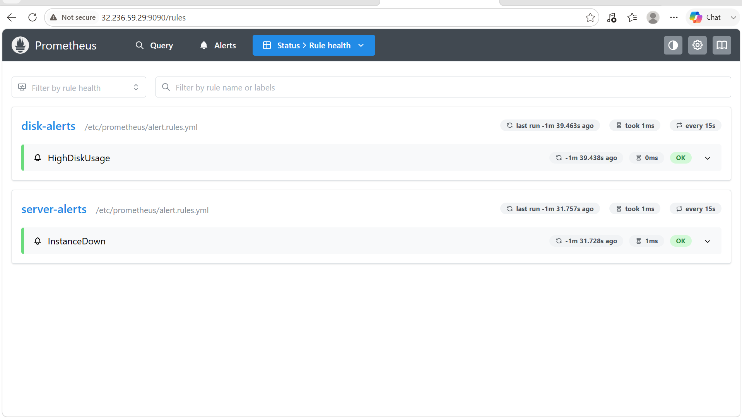

9. Create a custom Grafana dashboard using Prometheus metrics for specific insights.

PURPOSE:
- Visualize server performance in real time.
- Monitor CPU, memory, and disk utilization.
- Detect resource bottlenecks.
- Create a centralized monitoring dashboard for infrastructure.

OBJECTIVE: Create a custom Grafana dashboard that displays real-time system metrics collected by Prometheus, such as CPU usage, memory usage, disk usage, and system uptime.

EXPECTED OUTCOME:
Your custom dashboard will provide a real-time view of:
- CPU utilization
- Memory utilization
- Disk utilization
- Available memory
- System uptime
- Filesystem free space
- Network receive/transmit rates
- Disk read/write throughput
This gives you a practical infrastructure monitoring dashboard built on Prometheus metrics without relying on pre-built templates.

PREREQUISITES:
- Grafana installed and running
- Prometheus configured as a Grafana data source
- Node Exporter running
- Prometheus successfully scraping Node Exporter metrics

STEP BY STEP IMPLEMENTATION:

Step 1: Login to Grafana
Open:
http://<SERVER-IP>:3000
Example:
http://32.236.59.29:3000
Login using:
Username: admin
Password: <your-password>

Step 2: Create a New Dashboard
- Click Dashboards.
- Click New.
- Select New Dashboard.
- Click Add Visualization.
- Select the Prometheus data source.

Panel 1: CPU Usage
Title
CPU Usage (%)
Query
100 - (avg by(instance)(rate(node_cpu_seconds_total{mode="idle"}[5m])) * 100)
Visualization:
- Gauge or Time Series
Unit:
Percent (0-100)

Panel 2: Memory Usage
Title
Memory Usage (%)
Query
100 * (1 - (node_memory_MemAvailable_bytes / node_memory_MemTotal_bytes))
Visualization:
- Gauge
Unit:
Percent

Panel 3: Disk Usage
Title
Disk Usage (%)
Query
100 - (
node_filesystem_avail_bytes{mountpoint="/",fstype!~"tmpfs|overlay"}
*100
/
node_filesystem_size_bytes{mountpoint="/",fstype!~"tmpfs|overlay"}
)
Visualization:
- Gauge
Thresholds:
Value | Color
0–70 | Green
70–85 | Yellow
85–100 | Red

Panel 4: Available Memory
Query
node_memory_MemAvailable_bytes
Visualization
- Stat
Unit
bytes (IEC)

Panel 5: System Uptime
Query
time() - node_boot_time_seconds
Visualization
- Stat
Unit
seconds (s)

Panel 6: Filesystem Free Space
Query
node_filesystem_avail_bytes{mountpoint="/",fstype!~"tmpfs|overlay"}
Visualization
- Stat
Unit
bytes (IEC)

Panel 7: Network Receive
Query
rate(node_network_receive_bytes_total[5m])
Visualization
- Time Series
Unit
bytes/sec

Panel 8: Network Transmit
Query
rate(node_network_transmit_bytes_total[5m])
Visualization
- Time Series
Unit
bytes/sec

Panel 9: Disk Read Speed
Query
rate(node_disk_read_bytes_total[5m])
Visualization
- Time Series
Unit
bytes/sec

Panel 10: Disk Write Speed
Query
rate(node_disk_written_bytes_total[5m])
Visualization
- Time Series
Unit
bytes/sec

Arrange Dashboard:

+----------------------+----------------------+
| CPU Usage | Memory Usage |
+----------------------+----------------------+

+----------------------+----------------------+
| Disk Usage | Available Memory |
+----------------------+----------------------+

+---------------------------------------------+
| System Uptime |
+---------------------------------------------+

+----------------------+----------------------+
| Network Receive | Network Transmit |
+----------------------+----------------------+

+----------------------+----------------------+
| Disk Read | Disk Write |
+----------------------+----------------------+

Save the Dashboard
- Click Save Dashboard.
- Name it:
Infrastructure Monitoring Dashboard
- Click Save.

